 | 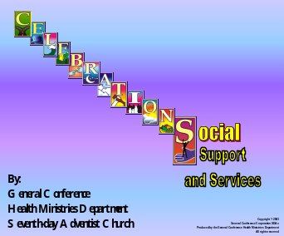
 | 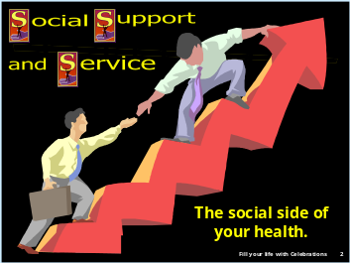 | *S is for social, support, and service, the social side of your health.  Social support is a vital factor in the health of individuals and society.
 |  | *Dan Harnon relates the following story: A man brought his dog to a veterinarian’s office.
 |  | The dog was stiff and appeared to be dead. However, this man did not want to face the fact that his dog was dead! The vet pronounced with certainty to the man “the dog is dead.”
 |  | *The man was upset and asked, “Doctor, is there no other examination you can perform?” I have to be absolutely certain that little Morty is gone before I can begin to deal with it and find peace!”
 |  | *For a moment the vet thought and muttered to himself, “What else can I do to make this man accept the reality that his dog is dead?” He suddenly had a bright idea and whispered quickly to his assistant, who immediately went to another room and
 | 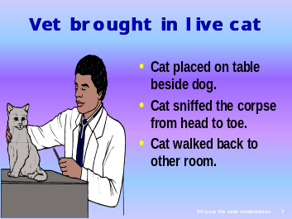 | *returned quickly with a big live cat. The cat was then placed on the table beside the dog and it started to sniff the corpse from head to tail. As soon as he finished sniffing the tail, the cat hopped down from the table and walked back to the other room.
 | 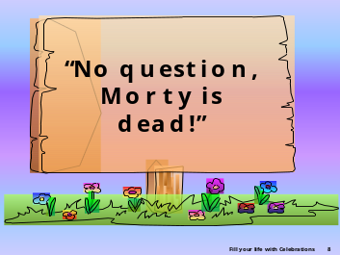 | *The vet then said, “No question whatsoever. Morty is dead.”
 |  | He proceeded to write a bill for $200. The man was shocked. “What? $200? I don’t understand. You mean you are charging $200 to verify that my dog is dead?”  “Not exactly,” the vet explained. “My examination was only $50.00. The other $150 covers the cat scan!” What a high price to pay for not being able to face up to the reality that his dog was dead!
 |  | *We need to face the reality that humankind is one family.
 | 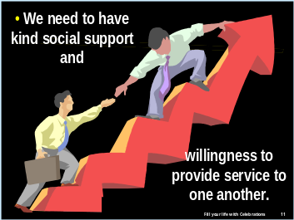 | We need social support as well as a willingness to provide such service to others. We are social beings. Selfishness and pride separate nations, kingdoms, tribes, communities, and families. Selfish interests drive wedges between us.
 |  | *Religion teaches us that all nations are one in the eyes of God.
 | 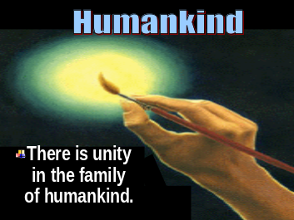 | *There is unity in the family of humankind.
 |  | *Regardless of the color of our skin, we are all of one family by creation, and we need to have compassionate attitudes to others in our society and a willingness to provide service to one another.
 | 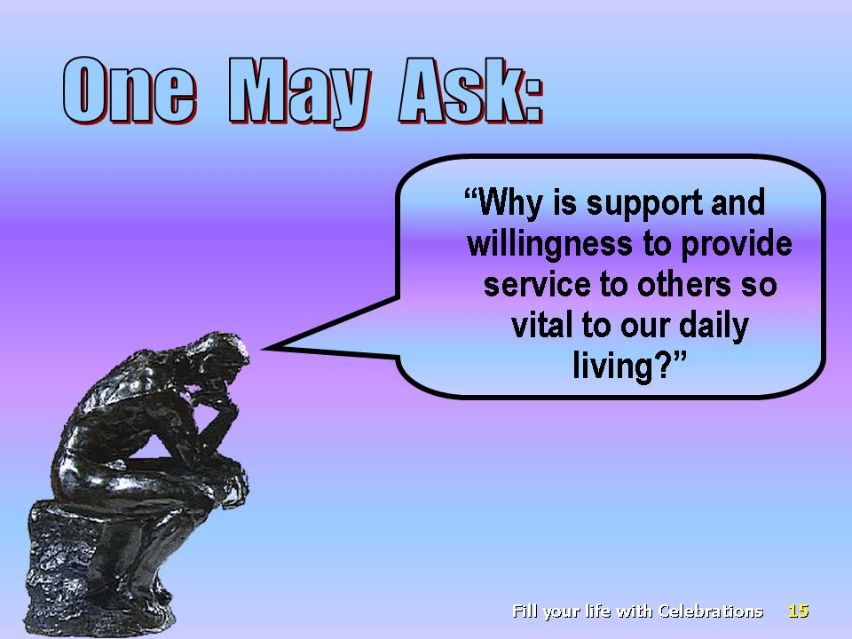 | *One may ask: “Why is support and willingness to provide service to others so vital to our daily living?”
 | 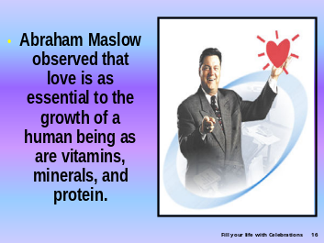 | The psychologist Abraham Maslow observed that love is as essential to the growth of a human being as are vitamins, minerals, and protein.
 | 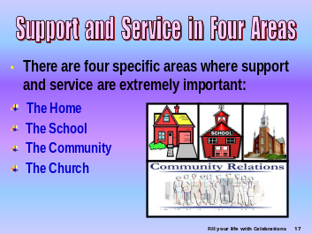 | *There are four specific areas where support and service are extremely important.
 | 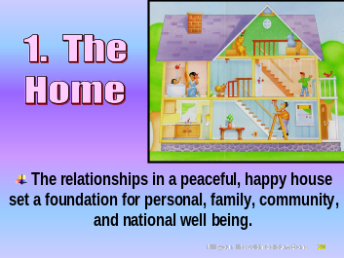 | 1. *The home: The relationships in a peaceful, happy house set a foundation for personal, family, community, and national well being.
 | 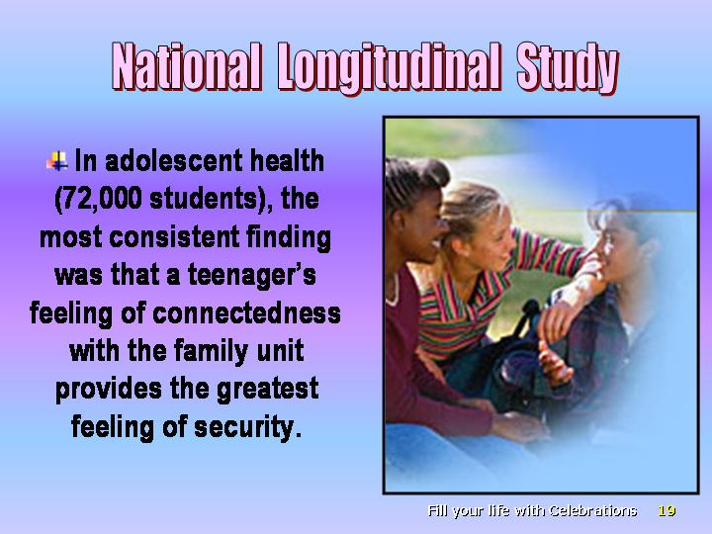 | *“In the National Longitudinal Study of adolescent health (72,000 students), the most consistent finding was that a teenager’s feeling of connectedness with the family unit provides the greatest feeling of security.
 | 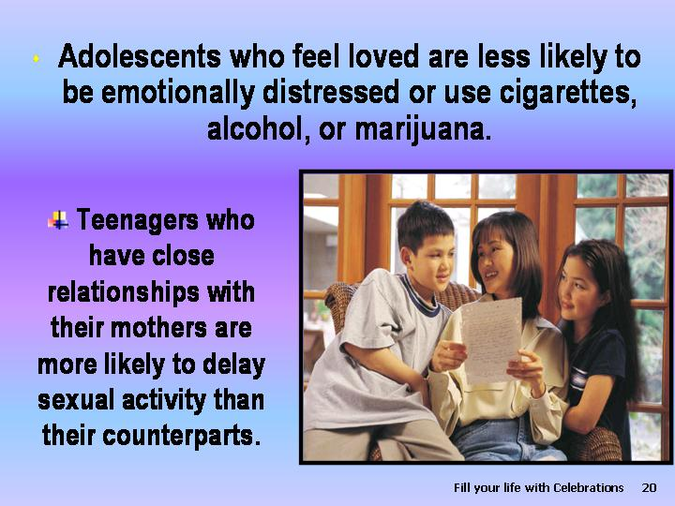 | *Adolescents who feel loved by parents are less likely to be emotionally distressed or to use cigarettes, alcohol, or marijuana.” Teenagers who have close relationships with their mothers are more likely to delay sexual activity than their counterparts. What Mom says helps to shape teen’s perceptions regarding sexual matters.
 | 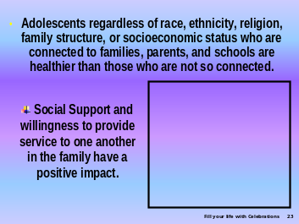 | *Adolescents regardless of race, ethnicity, religion, family structure, or socioeconomic status who are connected to families, parents, and schools are healthier than those who are not so connected. Many studies have shown the positive impact of social support and willingness to provide service to one another in the family.
 | 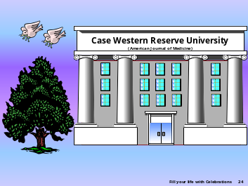 | *A study conducted in the Case Western Reserve University, published in the American Journal of Medicine,
 | 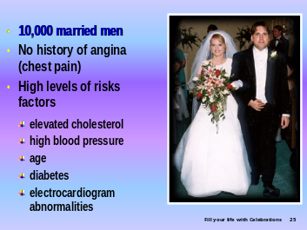 | involved *10,000 married men with no history of angina (chest pain), but with multiple risk factors such as elevated cholesterol, high blood pressure, age, diabetes, and electrocardiographic abnormalities.
 |  | *These men were 20 times more likely to develop new angina during the ensuing five years. It is interesting to note that those who answered “No” to the simple question, “Does your wife show you her love?” had twice as much angina as those who answered in the affirmative.
 | 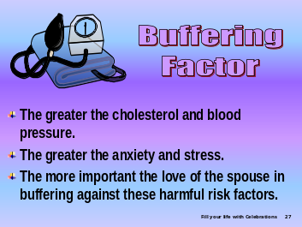 | *The higher the cholesterol and blood pressure, and the greater the anxiety and stress, the more important was the love of the spouse in buffering these harmful risk factors.
 | 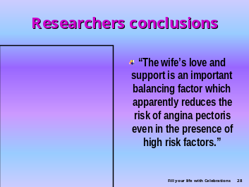 | *The researchers concluded: “The wife’s love and support is an important balancing factor, which apparently reduces the risk of angina pectoris even in the presence of high-risk factors.”
 | 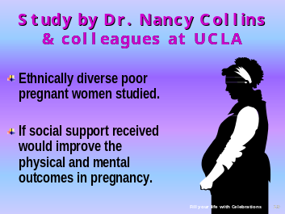 | *Dr. Nancy Collins at the University of California, Los Angeles, studied ethnically diverse, underprivileged, pregnant women to determine whether social support would improve the physical and mental outcomes of pregnancy.
 | 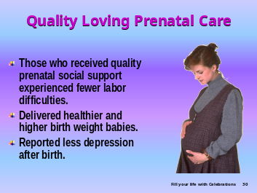 | *Those who received quality prenatal social support experienced fewer difficulties during labor, delivered healthier (as indicated by Dr. Virginia Apgar’s assessment method) and higher birth-weight babies. They also reported less maternal depression after birth.
 | 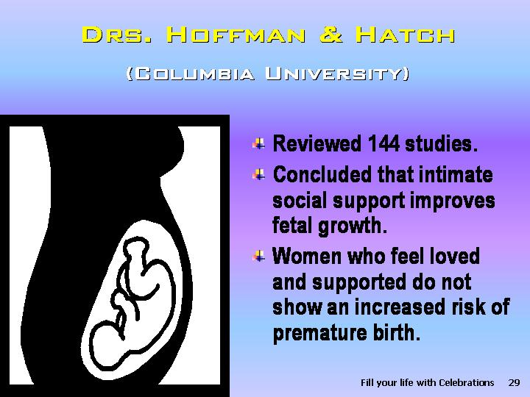 | In reviewing more than 144 studies, *Drs. Hoffman and Hatch at Columbia University concluded that intimate social support from a partner or a family member substantially improves fetal growth. In women who feel loved and supported, stressful life events during pregnancy do not increase the risk of premature birth.
 |  | *Social support definitely benefits both the pregnant female recipients as well as their unborn babies.
 | 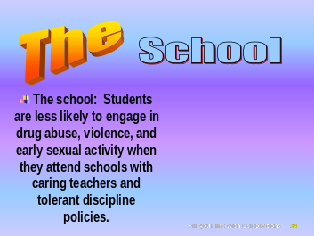 | 2. *The school: Students are less likely to engage in drug abuse, violence, and early sexual activity when they attend schools with caring teachers and tolerant discipline policies.
 |  | *Dr. David C. McClelland and his colleagues studied
 | 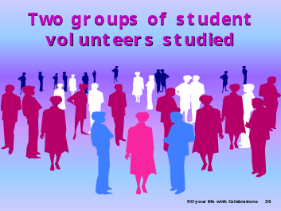 | *two groups of student volunteers.
 | 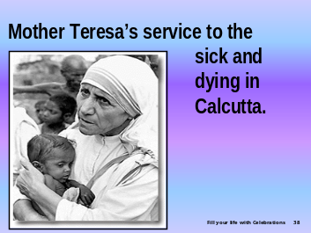 | *One group was asked to view a 50-minutes film of Mother Theresa’s loving service to the sick and dying in Calcutta’s worst slum—a video specially chosen to induce *a positive and caring emotional state.
 |  | *The other group of students was asked to view a powerful documentary film about World War II, *chosen to elicit negative emotions and anger.
 | 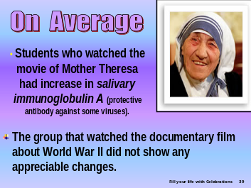 | *On average those students who watched the movie of Mother Theresa had a significant increase in salivary immunoglobulin A, a protective antibody against some viruses, whereas, the watched the documentary film about World war II did not show any appreciable changes.
 | 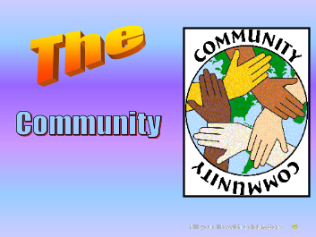 | 3. *The Community:
 | 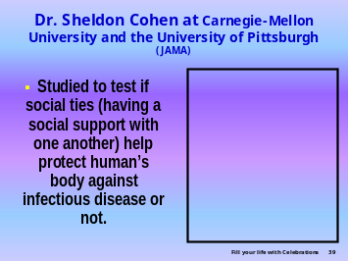 | • *Dr. Sheldon Cohen and his colleagues at Carnegie-Mellon University and the University of Pittsburgh conducted a study to assess whether social ties (having social support and willingness to provide service to one another) helps to protect the human body against infectious disease.
 | 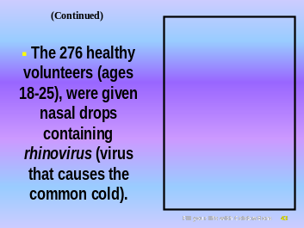 | *Two hundred seventy-six healthy volunteers, ranging in age from 18 to 55, were given nasal drops containing rhinovirus (the virus that causes the common cold).
 | 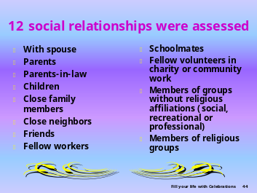 | *Thereafter, participation in 12 types of social relationships were assessed: relationship with 1. spouse, 2. parents, 3. parents-in-law, 4. children, 5. close family members, 6. close neighbors, 7. friends, 8. fellow workers, 9. schoolmates, 10. fellow volunteers in charity or community work, 11. members of groups without religious affiliations (social, recreational or professional), as well as 12. members of religious groups.
 |  | The research revealed that those who reported only one to three types of relationships had more than four times the risk of developing a cold than those reporting six or more various types of relationships. These differences were not fully explained by antibody titers (levels), smoking, exercise, amount of sleep, alcohol, vitamin C, or other variable factors.
 |  | *In addition, the researchers discovered that the diversity of relationships was more important than the total number of people to whom they spoke.
 | 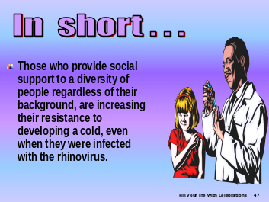 | *In short those involved in mutually supportive relationship with a diversity of people, regardless of their background, increase their resistance to infection with the rhinovirus.
 | 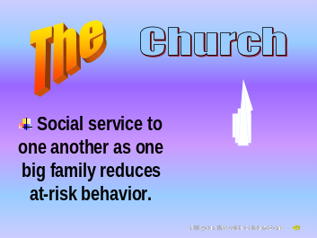 | 4.* The church: *Social service to one another as one big family reduces at-risk behavior.
 | 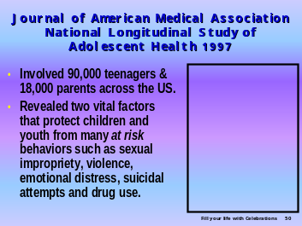 | *The National Longitudinal Study of Adolescent Health (ADD) published in the Journal of the American Medical Association in 1997 involved 90,000 teenagers and 18,000 parents across the Unites States.
 |  | This revealed that *two vital factors protect children and youth from many at-risk behaviors such as sexual impropriety, violence, emotional distress, suicide attempts, and drug use:
 | 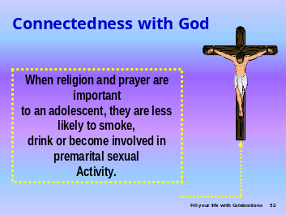 | *Connectedness with God. An adolescent to whom religion and prayer are important is less likely to smoke, drink, or become involved in premarital sexual activity.
 | 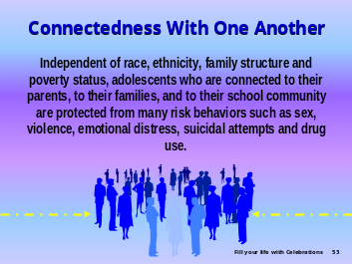 | *Connectedness with one another. Independent of race, ethnicity, family structure, or poverty status, adolescents who connected to their parents, to their families, and to their school community are protected from many risky behaviors such as premarital sex, violence, suicide attempts, drug use, and those related to emotional distress.
 |  | * “No man is an island unto himself.*” We all long to be accepted and connected with one another for support and encouragement. Social acceptance and support reduce the need to use drugs.
 |  | Seeing the outstanding benefits of social support and willingness to provide service to one another, we can understand why meaning is added to the statement made many years ago: *“Christian kindness and earnest consecration are constantly to be manifest in the life.”
 |  | *There are many verses in the Bible giving specific instruction on how to practice kindness and to express loving social support to one another. Examples are:
 |  | *New Testament Love one another (John 13:35);  - Forgive one another (Col. 3:13);  - Accept/receive one another (Rom. 15:7);  - Pray for one another (James 5:16);  - Comfort one another (1 Thess. 4:18);  - Fellowship with one another (1 John 1:7);  - Be kind to one another (Eph. 4:32);  - Show compassion to one another (1 Pet. 3:8);  - Be hospitable to one another (1 Pet. 4:9); etc.
 |  | *Old Testament  • Be hospitable to strangers (Gen. 18:2-5);  • Do not pass along false reports (Exod. 23:1);  • Do what is right (Mic. 6:8);  • Honor your parents (Exod. 20:12);  • Respect your neighbors (Exod. 20:15);  • Love your neighbors (Lev. 19:18);  • Real friends stick closer than a brother  (Prov. 18:24).
 | 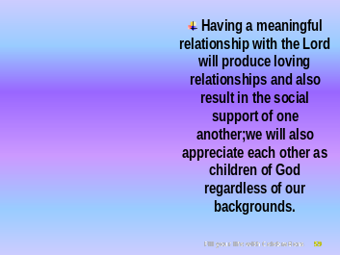 | *Having a meaningful relationship with the Lord will produce loving relationships and also result in the social support of one another; we will also appreciate each other as children of God regardless of our backgrounds.
 | 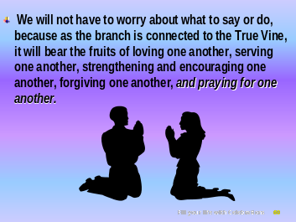 | *We will not have to worry about what to say or do, because as the branch is connected to the True Vine, it will bear the fruits of loving one another, serving one another, strengthening and encouraging one another, forgiving one another, and praying for one another.
 | 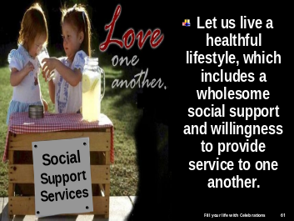 | *Let us live a healthful lifestyle, which includes a wholesome social support and willingness to provide service to one another,
 |  | * allowing God to fill our lives with CELEBRATIONS.
 | 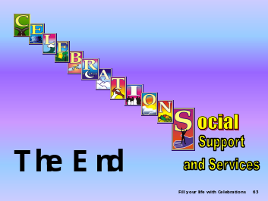

Medalie JH, Gouldbourt U. “Angina pectoris among 10,000 men. II. Psychosocial and other risk factors as evidenced by a multi-variate analysis of a five-year incidence study,” AJM, 1976, 60 (6):910-21.
Collins NL, Dunkel-Schetter C, Lobel M, et al. “Social support in pregnancy: Psychosocial correlates of birth outcomes and postpartum depression,” Journal of Personality and Social Psychology, 1993, 65: 1243-58.
? Hoffman S, Hatch MC. “Stress, social support and pregnancy outcome: a reassessment based on recent research,” Paediatric & Perinatal Epidemiology, 1996, 10(4):380-405.
? National Longitudinal Study on Adolescent Health.
? McClelland DC, Kirshnit C. “The effect of motivation arousal through films on salivary immunoglobulin A,” Psychology and Health, 1988, 2:31-52. Published in the Microbiology and Molecular Biology Review (vol 62-no.1 March 1998, pp. 71-101). Provides further supportive evidence of improved oral bacterial resistance.
Cohen S, Doyle WJ, Skoner DP, et al. “Social ties and susceptibility to the common cold,” JAMA, 1997, 277:1940.
Blum W, Rinehart M.“Reducing the Risk: Connection That Make a Difference in the Lives of Youth,” Division of General Pediatrics and Adolescent Health, based on the first analysis of Ad Health data,” Protecting adolescents from harm: Findings from the National Longitudinal Study on Adolescent Health,” JAMA, September 10, 1997.
Medical Ministry, p. 204.

