Slide 1 | 
Slide 2 | 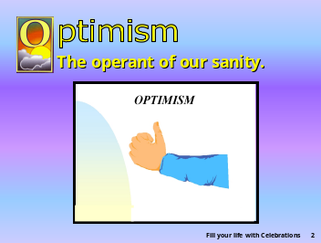 | *O is for optimism, the operant of our sanity.
Slide 3 | 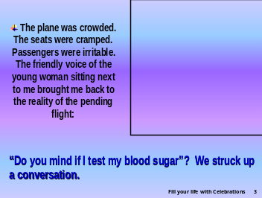 | *The plane was crowded. It was the beginning of another long-haul flight. It seemed as if the seats were more cramped than usual! The overhead lockers were full and passengers were already irritable because their carry-on bags were separated from where they were sitting.  I was lost in thought about the mad crush and rush of our existence when the friendly voice of the young woman sitting next to me brought me back to the reality of the pending flight: “Do you mind if I test my blood sugar?” Of course I didn’t. We struck up a conversation. She was a doctoral student completing her dissertation in cancer research.
Slide 4 |  | *She was vivacious, bright, and cheerful. And then, as if it were not a serious matter, she said: “I have had diabetes for 22 years. I am so blessed to have had such a wonderful life and so much opportunity.” She then witnessed further about her faith in God and her commitment to Him.
Slide 5 | 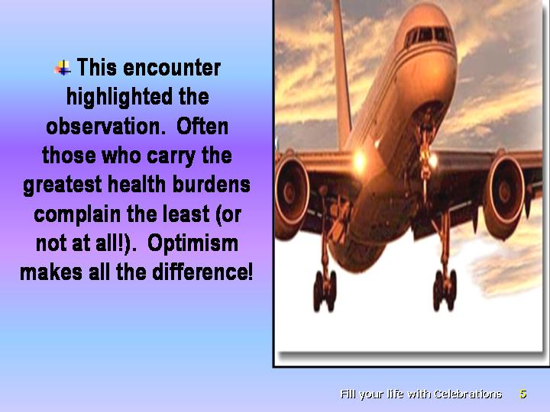 | *This encounter highlighted an observation of many clinicians: Often those who carry the greatest health burdens complain the least (or not at all!). Optimism makes all the difference!
Slide 6 |  | *An optimist tends to look at the bright side of life.
Slide 7 |  | *Two people looking out from the same jail bars may see different things.
Slide 8 |  | depending on whether they are *an optimist or a pessimist:
Slide 9 | 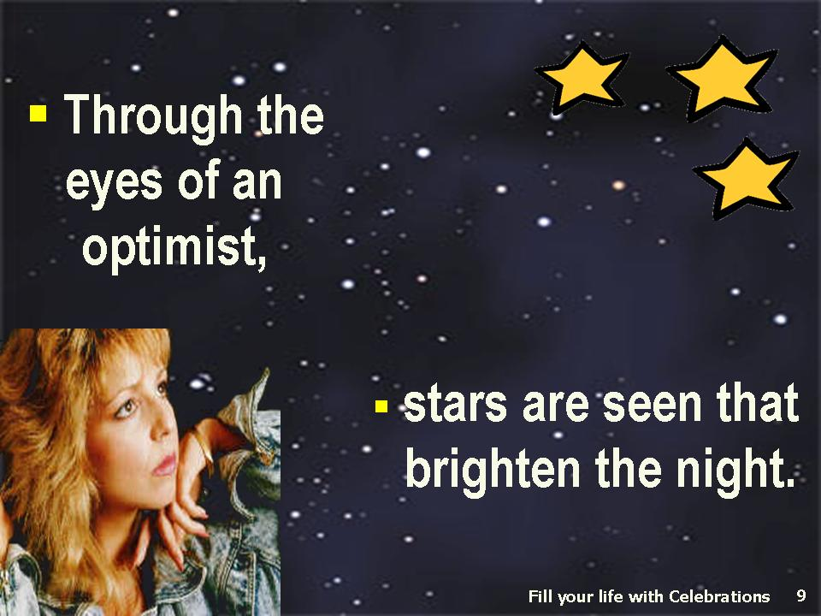 | *the optimist will see the beautiful stars that brighten the night;
Slide 10 | 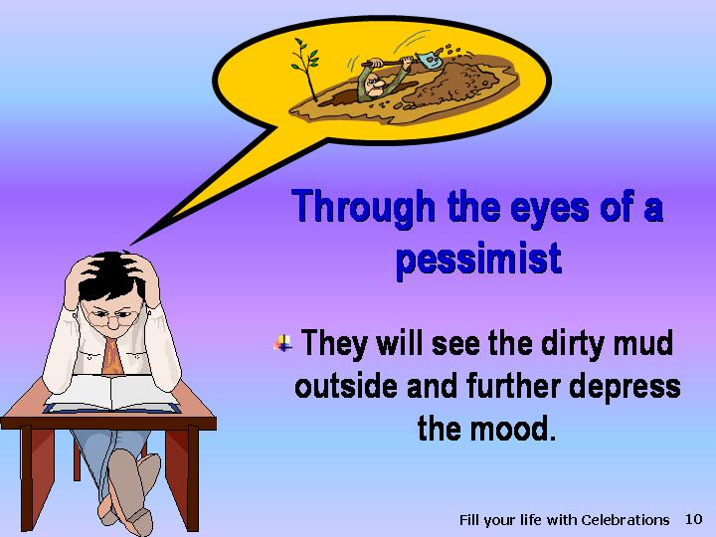 | *the pessimist will see the dirty mud outside and further depress his or her mood.
Slide 11 |  | *Through the eyes of an optimist, the glass is seen as half full,
Slide 12 |  | while *through the eyes of a pessimist, the glass is seen as half empty.
Slide 13 |  | *Optimism is indeed the face of our faith.
Slide 14 |  | *It is built on:  - hope and trust in God  II belief that He can work things out for our best,
Slide 15 |  | based on the verse in Romans 8:28  *“We know that all things work together for good to them that love God” (NKJV).
Slide 16 | 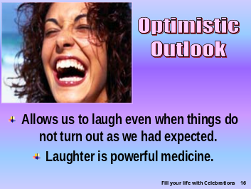 | *Therefore, an optimist can laugh even when things do not turn out the way expected. The optimist has proved that laughter is a powerful medicine. A pessimist finds it difficult to laugh. In choosing to be optimistic, we open the door to laughter and its beneficial effects.
Slide 17 | 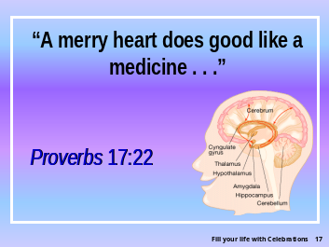 | Here is an interesting story of someone who discovered that *“A merry heart does good like a medicine” as stated in Proverbs 17:22.
Slide 18 | 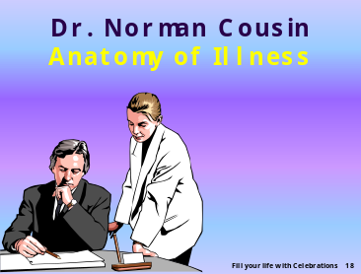 | *Norman Cousins, the author of a book entitled Anatomy of Illness, was the editor of the Saturday Review for more than 30 years and an adjunct professor of psychiatry and biobehavioral science at the University of California, Los Angeles. In that particular book he strongly emphasized the importance of cheerfulness in health.
Slide 19 | 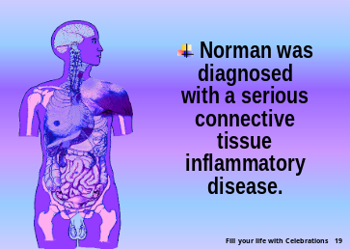 | *He relates specifically his personal experience of how he suffered from a serious collagen disease. In August 1964 he had a widespread inflammatory condition of collagen, the body's connective tissue (the fibrous substances that bind the cells together).
Slide 20 | 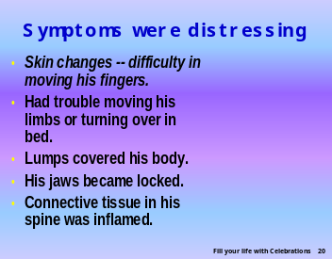 | - *The skin of his hands became thick, inelastic, tight, smooth, and shiny, and this caused great difficulty in moving his fingers.  - He also had difficulty in moving his limbs and even in turning over in bed.  - There were lumps (nodules) over all of his body indicating the widespread (systemic) nature of this disease.  - His jaws could hardly move apart, due to the connective tissue that became inflamed and thickened; his mouth was almost locked.
Slide  21 | 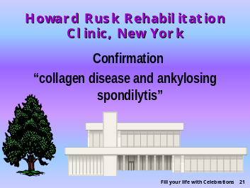 | *Dr. William Hitzig, his doctor, called in experts from Dr. Howard Rusk’s rehabilitation clinic in New York City. After they examined him, they confirmed that he had a collagen disease as well as ankylosing spondylitis, which means that the connective tissue in the spine was also markedly affected and contracted.
Slide 22 | 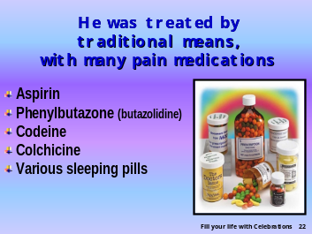 | *Doctors prescribed different pain-killing and sedative drugs for him, including:  ∙ aspirin  ∙ phenylbutazone (butazolidine)  ∙ codeine  ∙ colchicine  ∙ various sleeping pills
Slide 23 | 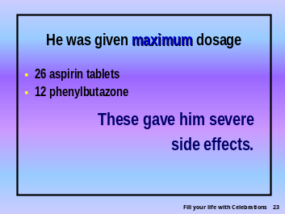 | *He was given the maximum dosage of 26 aspirin tablets and 12 phenylbutazone tablets daily.
Slide 24 | 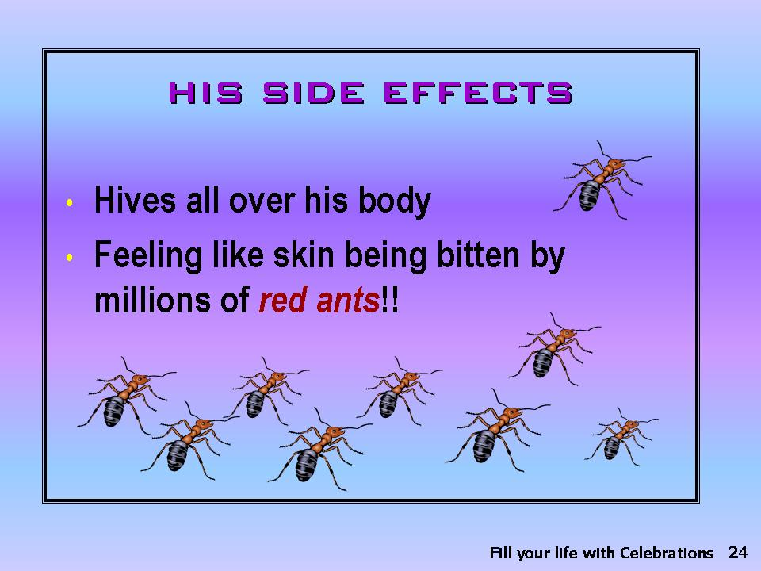 | As a result he developed a reaction that *caused hives all over his body, and he felt as though his skin was being “bitten by millions of red ants!” He was hypersensitive to virtually all these medications.
Slide 25 |  | *Statistics show that only one out of 500 will recover from this particular disease. It is usually a progressive disease with a guarded prognosis.
Slide 26 | 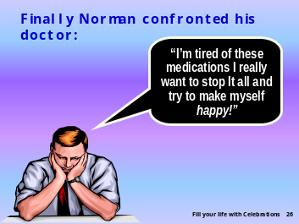 | *Norman Cousins felt awfully miserable because of the pain, and one day he discussed this with his doctor: “I am really tired of all these medications plus their side effects. I really want to quit and try to make myself happy.
Slide 27 |  | *So he decided to call Allen Funt, the producer of the popular TV program Candid Camera to send him some classically amusing movies along with a movie projector. The nurse was instructed in its use.
Slide 28 | 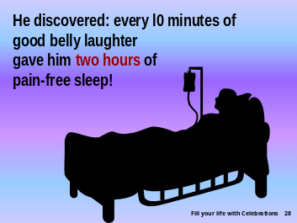 | *Surprisingly he discovered that when he laughed, his pain was relieved. He noticed that every 10 minutes of genuine belly laughter would have an analgesic effect, giving him at least two hours of pain-free sleep. When the pain-killing effect of the laughter wore off, he would switch the motion picture projector on again, and this would lead to another pain-free sleep interval. Sometimes the nurse would read to him from a collection of humorous books. Cousins really enjoyed these humorous movies and stories. The only negative side of this program was that Norman laughed too loudly and disturbed the other patients. So arrangements were made for him to move out of the hospital to a hotel room.
Slide 29 | 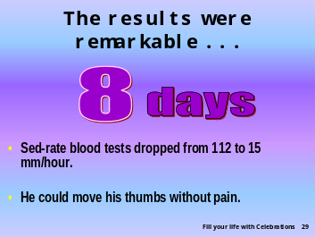 | *However, his sedimentation rate, a blood test that shows the severity of the inflammation, was constantly monitored. It went from 112 mm/hour down to 15 mm/hour and at the end of the eighth day, he was able to move his thumbs without pain.
Slide 30 |  | Next:  ∙ *The gravel-like lumps (nodules) on his neck and back began to shrink.  ∙ He recovered sufficiently to return to his full-time job at the Saturday Review.
Slide 31 | 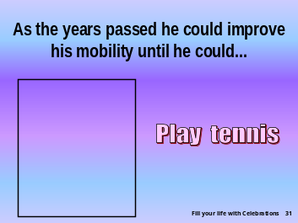 | *Year by year his mobility improved until he could:  ∙ play tennis
Slide 32 | 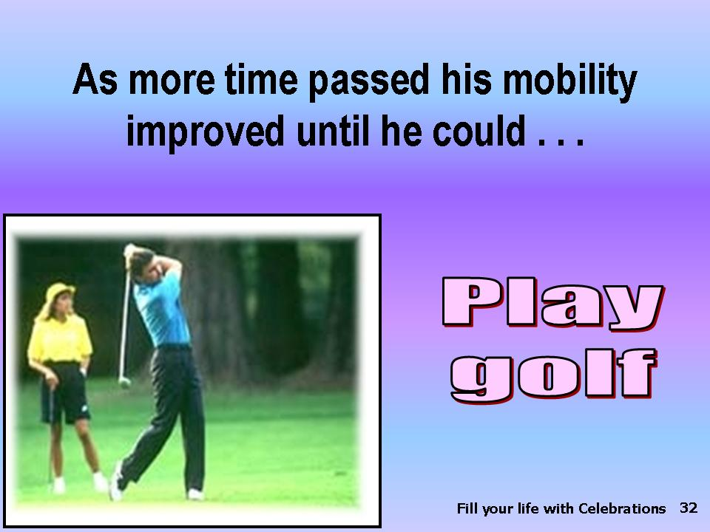 | *play golf
Slide 33 | 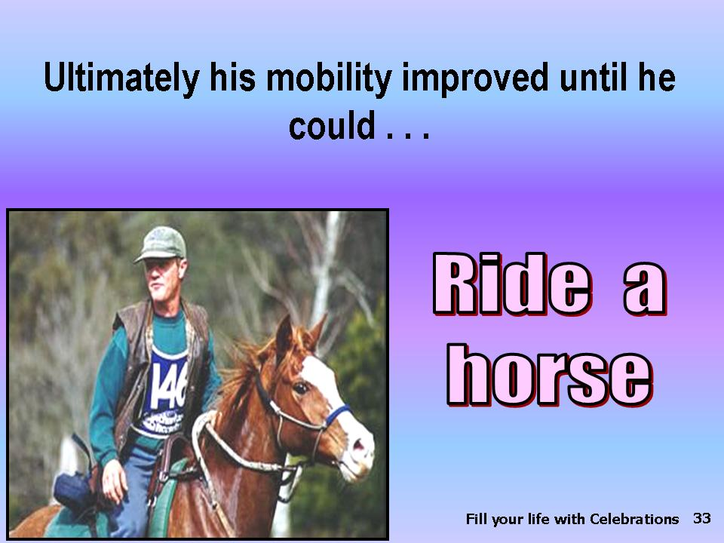 | *ride a horse
Slide 34 |  | *hold a camera with a steady hand
Slide 35 | 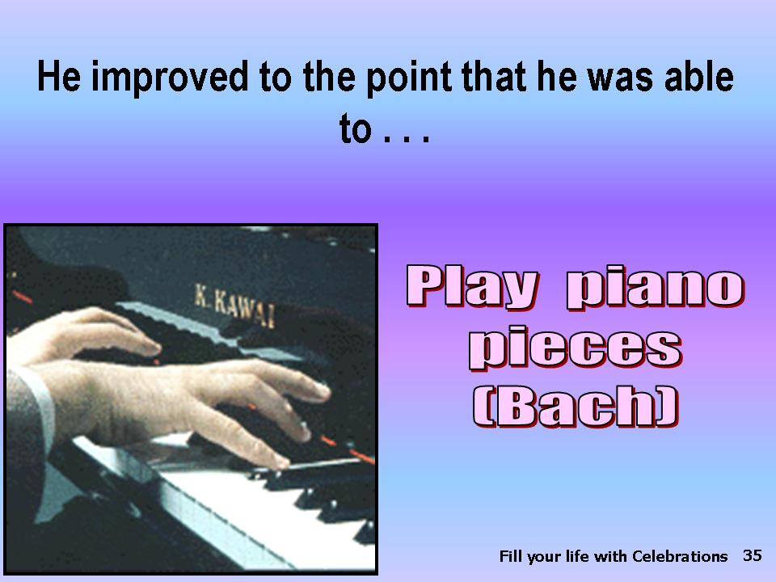 | *play piano pieces.
Slide 36 |  | Laughter is surely a powerful medicine. *Let us take a few moments to see what a hearty laugh may do for our bodies:
Slide 37 | 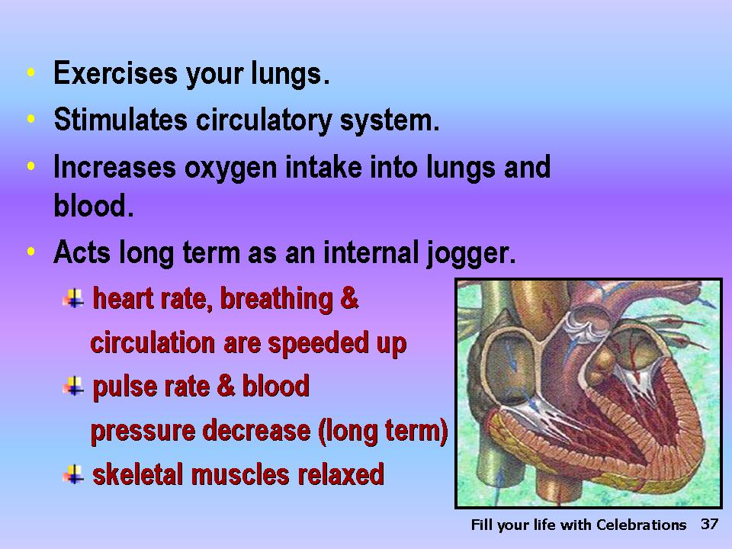 | - *It exercises the lungs.  - It stimulates the circulatory system.  - It increases the oxygen intake into the lungs and thence distributed by the blood to the cells.  - It is like an internal jogger:  - the heart rate, breathing, and circulation will speed up after good and hearty laughter;  - subsequently the pulse rate and blood pressure will decrease;  C. the skeletal muscles may then become relaxed.
Slide 38 | 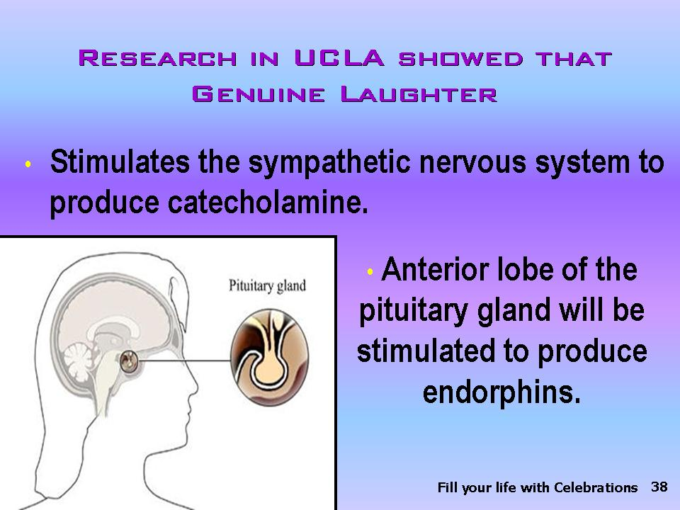 | *Studies show that each time a person is happy and has laughed genuinely (not forced laughing where one only laughs in a superficial way), the sympathetic nervous system is stimulated which in turn produces catecholamines. These catecholamines then stimulate the anterior lobe of the pituitary gland to produce endorphins.
Slide 39 | 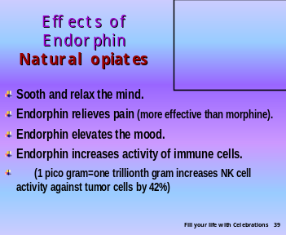 | - *Endorphins are the body’s natural opiates that soothe and relax the mind. They can relieve pain more effectively than morphine.  - Endorphins elevate the mood.  - Endorphins may increase the activity of the immune cells.  Laughter is surely a powerful medicine, as stated in the Bible, which has again been supported by the experience of many!
Slide 40 |  | *We can truly be happy and have genuine laughter especially when we have complete trust in God, knowing He is in control of our lives.
Slide 41 | 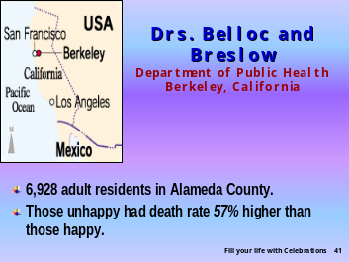 | *The twentieth-century lifestyle studies by Drs. Belloc and Breslow from the Department of Public Health, Berkeley, California, reinforce that longevity has a close connection with the happy disposition of people. This study involved 6,928 adult residents of Alameda County, and the results showed that those who were generally unhappy had a death rate 57-percent higher than those who were generally very happy.
Slide 42 |  | *It is not always possible to be happy and laughing, but a positive attitude can be cultivated. Studies show a positive optimistic attitude carries beneficial effects.
Slide 43 | 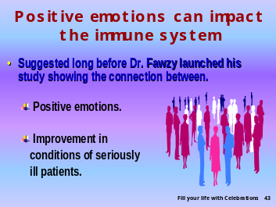 | *Long before Dr. Fawzy launched his study showing the connection between the positive emotions and improvement in the condition of seriously ill patients, some isolated cases had suggested that positive emotions could impact one’s health.
Slide 44 | 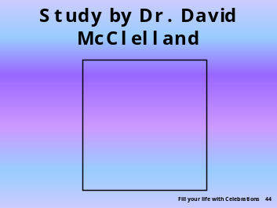 | *An interesting study was done by Dr. David McClelland who showed a group of students a photograph of
Slide 45 |  | *a couple sitting on a bench by a river.
Slide 46 |  | *He requested that each student write a story about this couple to gain greater insight into each student’s subconscious perceptions and projections
Slide 47 | 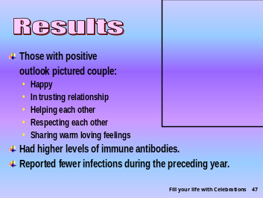 | . Here is what the study revealed:  - *Those who wrote stories depicting the positive outlook they had of this couple, picturing them to be enjoying a happy, trusting relationship, helping each other, respecting each other, and sharing warm loving feelings with each other, demonstrated higher levels of immune antibodies and also reported fewer infections diseases during the preceding year.
Slide 48 | 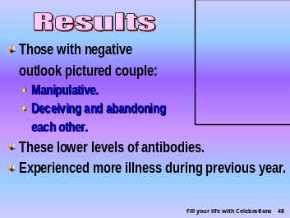 | - .*Those who wrote stories depicting a negative outlook of this couple, in which they were seen to be manipulating, deceiving, or abandoning each other, demonstrated lower levels of immune antibodies and reported experiencing significantly more illness during the previous year.  Just thinking well about others can positively impact immunity. At the same time we can see that thinking negatively about others may cause illness to oneself.
Slide 49 |  | No wonder Proverbs 17:22 (NKJV) continues, *“A broken spirit dries the bones.”
Slide 50 | 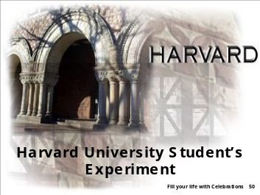 | *An experiment was conducted with students at Harvard University after they had taken a comprehensive personality test
Slide 51 | 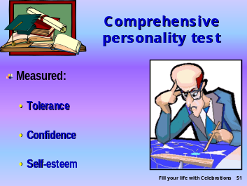 | that measured their *tolerance, confidence, and self-esteem.
Slide 52 | 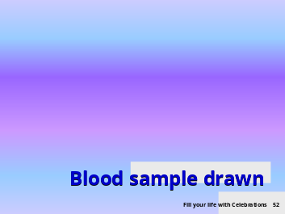 | *A blood sample was drawn
Slide 53 | 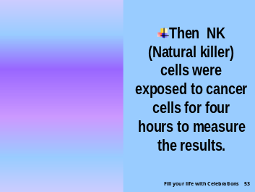 | and *NK cells were isolated and then exposed to cancer cells for a 4-hour period.
Slide 54 | 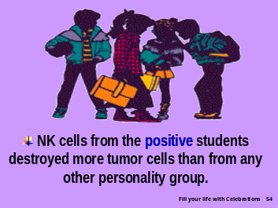 | The results showed:  ∙ *NK cells from students who have a healthy, positive attitude and personality destroyed more cancer cells than any other personality group.
Slide 55 | 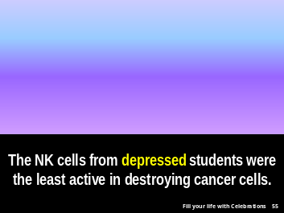 | *NK cells from students who ranked very high on the depression scale in the personality test, who were inclined to withdrawal and maladjustments and had low self-esteem, were the least active in destroying cancer cells.
Slide 56 | 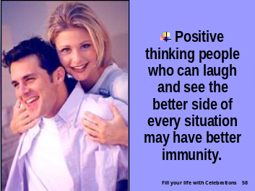 | *People who are tolerant and have a high self-esteem and confidence may be able to see the better side of every situation and consequently enjoy better health.
Slide 57 |  | *To be healthy, God encourages us to be free from evil and unwise thoughts.
Slide 58 |  | *“Be not wise in thine own eyes: fear the Lord, and depart from evil. It shall be health to thy navel, and marrow to thy bones” (Prov. 3:7,8, KJV)
Slide 59 | 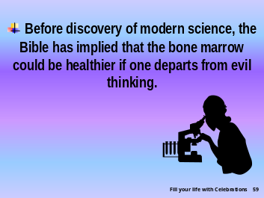 | How interesting that the Bible uses the analogy of the bone marrow as being a source of health. *The discoveries of modern science have identified the bone marrow as an important site where the immune cells are produced. Our resistance to disease finds its anatomical base in the bone marrow.
Slide 60 |  | * Let us live a healthful lifestyle, which includes having an optimistic view of life toward ourselves as well as toward others,
Slide 61 |  | *so God can fill our lives with CELEBRATIONS!
Slide 62 | 

Coussins N. Anatomy of an Illness as Perceived by the Patient (New York: W. W. Norton & Company, Inc. 1979).
? Berkman LF, Syme SL. “Social networks, host resistance, and mortality: a nine-year follw-up study of Almeida County residents,” Am J Epidemiol 1979 Feb;109(2):186-204.
? McClelland DC. “Motivational factors in health and disease,” American Psychologist, 1989,44(4):675-83.
? Dreher H. The Immune Power Personality (New York: Dutton Books, 1995).
? Kiecolt-Glaser Jk, Garner W, Speicher CE, Penn G, and Vlaser R. “Psychosocial Modifiers of Immunocompetence in Medical Students, ”Psychosomatic Medicine, 46 (1984).

