Slide 1 | 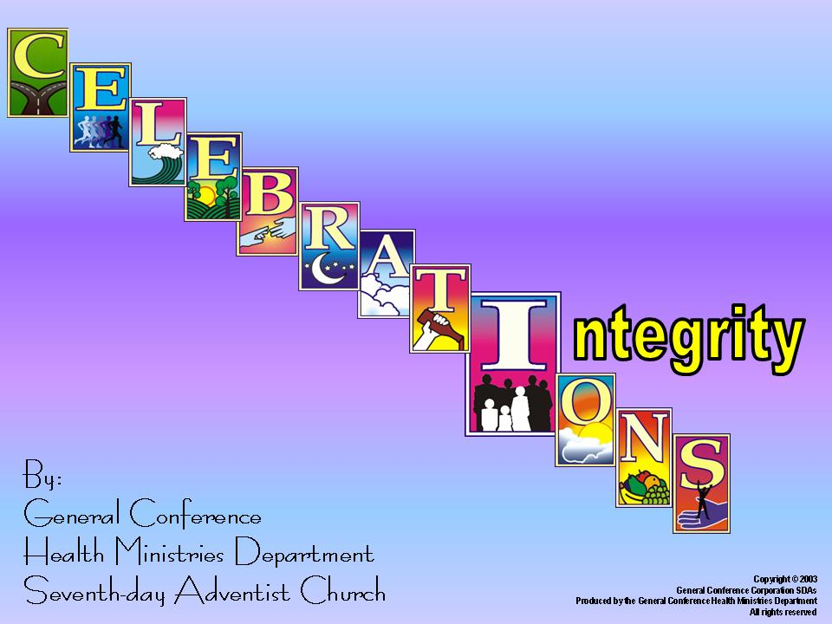
Slide 2 |  | *I is for integrity, the incorruptibility of our honesty.

Slide 3 | 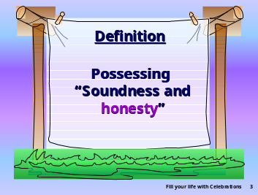 | *According to Webster's dictionary, “integrity” means, “The quality or state of being of sound moral principle, uprightness, honesty and sincerity.” Possessing wholeness and soundness means that we need to be honest with others and ourselves. There are many aspects of character but integrity is one of the more important. “Nations rise and fall with the character of their people. If any nation is to survive and prosper, then present and future citizens must be committed to high standards and values.”
Slide 4 | 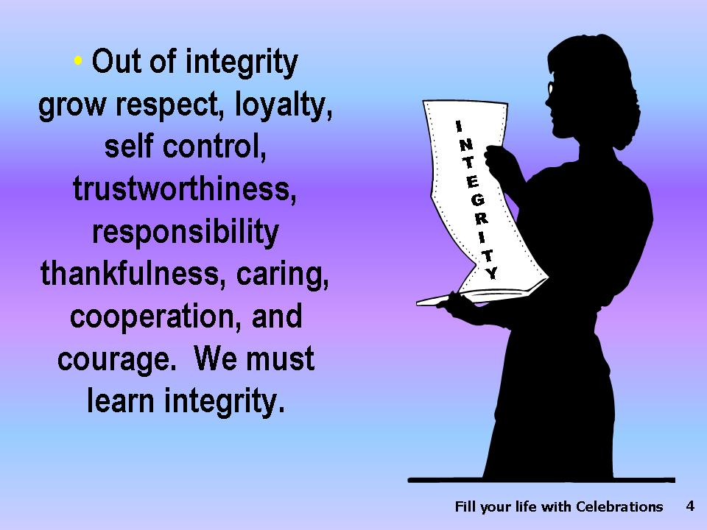 | *Out of integrity grows respect, loyalty, self control, trustworthiness, responsibility thankfulness, caring, cooperation, and courage. We are not born with integrity; we cannot buy integrity; we must learn integrity.
Slide 5 | 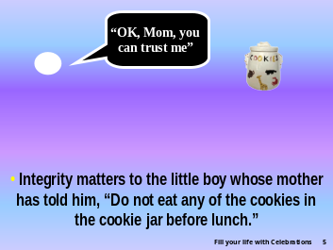 | *Integrity matters to the little boy whose mother has told him, “Do not eat any of the cookies in the cookie jar before lunch.”  “OK, Mom, you can trust me”  During midmorning while Mom is upstairs cleaning, he walks quietly  into the kitchen and we all know he is tempted to take a cookie in  spite of his promise. After all he was present when Mom was baking  those very special treats. He was tantalized at the time with the  enticing fragrance of butter, sugar, and chocolate erupting through the  vents of the oven. Since he gave his word, his promise, he would have to  ignore this strong temptation and refuse to take one of those six-inch double-  chocolate, praline-pecan-laced sweet morsels of heavenly food.  Although at six he is not old enough to know the meaning of the  word integrity, he has been taught that honesty is an important  character trait. So honesty is another synonym for integrity.
Slide 6 | 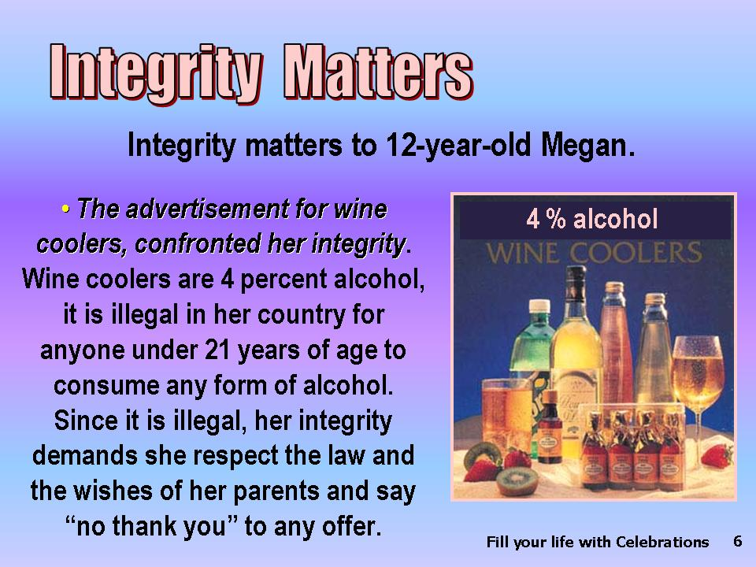 | *Integrity matters to 12-year-old Megan. When she read her first advertisement for wine coolers, she confronted her integrity. She had learned in school that wine coolers are 4 percent alcohol, that the brewing industry has deliberately targeted young people with these fruit-flavored “thirst quenchers.” She knows it is illegal in her country for any youth under 21 years of age to consume any form of alcohol. Her mother has prepared her for the time not too distant that she will be offered a fruited alcohol beverage. Since it is and will be illegal, her integrity demands she respect the law and the wishes of her parents and as a teen-ager say “no thank you” to that first offer.
Slide 7 | 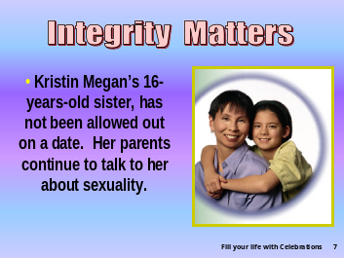 | *Integrity matters to all members of this family including Kristin, Megan’s 16-year-old sister, who until now has not been allowed out on a date. Her parents continue to talk to her about sexuality. This is not always easy.
Slide 8 | 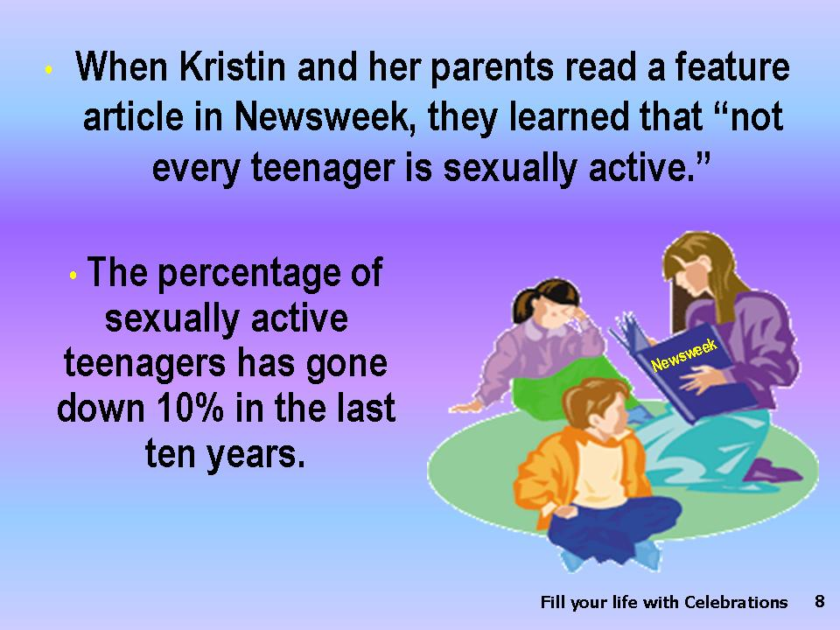 | A good chance came recently *when Kristin and her parents read a feature article in Newsweek, and learned that “not every teenager is sexually active.” A significant percentage of high-school girls are abstinent. In the U.S. the percentages of those sexually active have gone down in the last ten years by 10 percent. Teenage sex is a risky business, especially for girls, for they are more vulnerable to sexually transmitted diseases (STDs). The earlier they initiate sexual intercourse, the more likely they are to become infected.
Slide 9 | 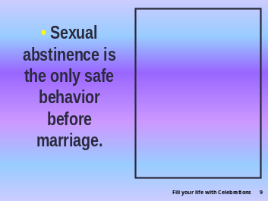 | *Sexual abstinence is the only safe behavior before marriage.  Virtually all STDs that can be transmitted through vaginal intercourse can be spread orally or anally.
Slide 10 | 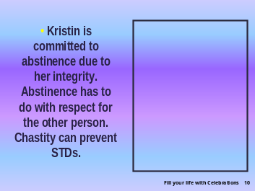 | *Kristin is committed to abstinence due to her integrity, her strong family ties, and her deep spiritual convictions. Abstinence has to do with respect for the other person. Sexually active people often do not know if they have an STD, especially Human Immune Virus (HIV) infection, for even a test may not reveal the virus for several months. Chastity can prevent the spread of STDs and their resultant damage to the infected person's reproductive capabilities.  Having read the article with Kristin, her mom and dad were able to emphasize several points. They pointed out that the sex drive is one of the most powerful. It has the power to give life, and it has the power to take life. HIV-IDS is the leading killer of young people in some countries, and it will kill everyone who becomes infected.
Slide 11 | 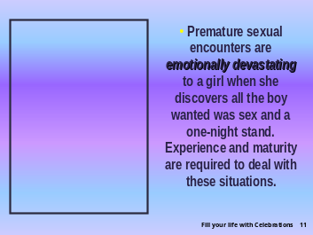 | *Premature sexual encounters are emotionally devastating to a girl especially when she discovers all the boy wanted was sex and a one-night stand. Young people are wise to save themselves for their future spouse. Experience and maturity are required to deal with these situations.
Slide 12 | 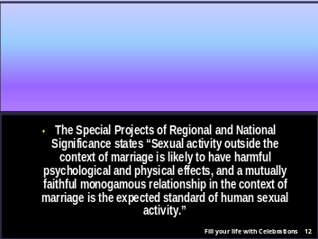 | The guidelines of the Special Projects of Regional and National Significance states that *“Sexual activity outside the context of marriage is likely to have harmful psychological and physical effects, and a mutually faithful monogamous relationship in the context of marriage is the expected standard of human sexual activity.” Major medical groups and supporters of comprehensive sex education like The Sexuality Information and Education Council agree that abstinence should be promoted as a first choice in sex education.
Slide 13 |  | *More than one third of U.S. high schools teach abstinence until marriage, and private organizations teach abstinence in all 50 states. Individuals wishing to make a fresh start can pledge to themselves to be a “born-again-virgin” or a “secondary virgin” or a “renewed virgin.” So Kristin, her mother, and her dad have lots of support. Kristin is not alone.
Slide 14 | 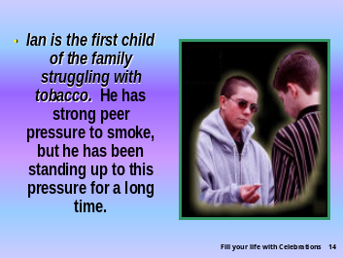 | *Ian is the first child of the family; he is 18 years old, old enough to vote. He has been driving a car for two years and is still struggling with tobacco. Not that he is a smoker. He has strong peer pressure to smoke and even chew tobacco, but he is strong and has been standing up to this pressure for a long time. He is now concerned about his own health. His friends smoke, and in order to be with them he has to breathe secondhand smoke. He is also concerned about the other members of his family when his friends come around and expose his siblings to this environmental tobacco smoke (ETS). ETS causes coughing, phlegm, discomfort, and reduced lung function—even death in nonsmokers.
Slide 15 | 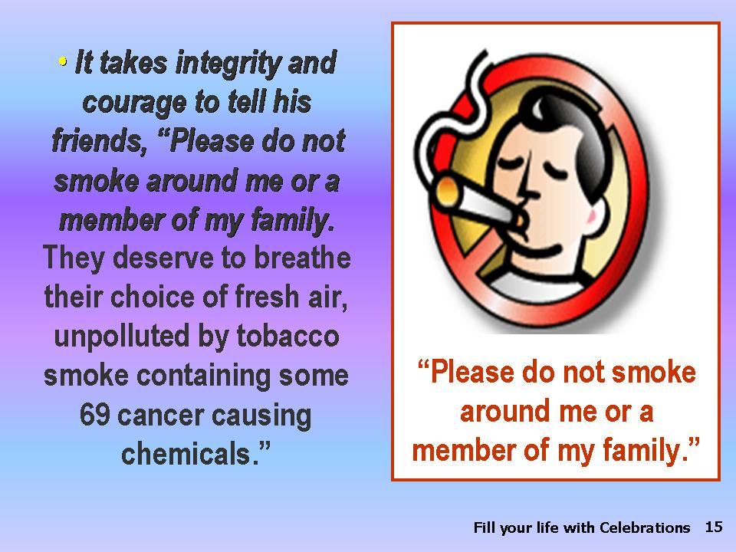 | *It takes integrity and courage to tell his friends, “Please do not smoke around me or members of my family. They deserve to breathe their choice of fresh air, not polluted tobacco smoke containing some 69 cancer causing chemicals.”
Slide 16 | 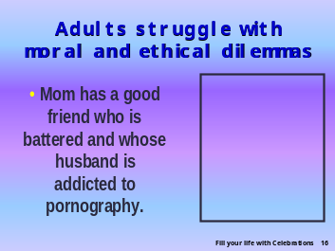 | *Not only children but adults struggle with moral and ethical dilemmas that test their integrity. Mom has a good friend who is battered and whose husband is addicted to pornography. What should and can she do to help her good friend Carol?
Slide 17 | 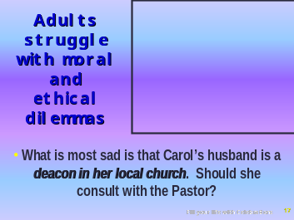 | What is most sad is that Carol's husband is a deacon in her local church. Should she consult with the Pastor?
Slide 18 |  | *Three to four hundred new pornography websites are opening per day.  Large numbers of people are spending increasing time on a daily basis, feeding their minds on devastating material. Integrity is eroded and destroyed during the process of viewing, as well as the production of, pornographic material. Children are not only the victims and subjects of this scourge, but are lured by chat-rooms and pop-up ads into a quagmire of pornography.
Slide 19 |  | *What chance do our children stand when those in church leadership and sometimes even their own parents have problems with pornography? Carol frequently suffers from verbal, as well as physical, abuse. Violence in the home is world wide. So far we have seen that every member of this family struggles with issues of integrity.
Slide 20 | 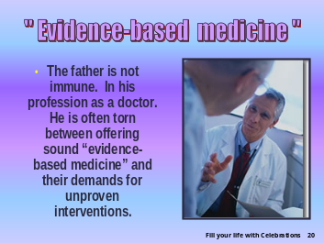 | *The father is not immune. With him it is in his profession as a doctor. He is often torn between offering sound “evidence-based medicine” to his patients and their demands for unproven interventions. Recently hormone replacement therapy has undergone a revolution because of a large study. The situation is now confusing to many women who have been taking it to relieve menopausal symptoms and reduce risks of heart disease. At about this same time a whole nutriceutical market has emerged, pushing soy products and a host of herbal remedies. The phytoestrogens in soy are promised to relieve menopausal symptoms.  In six studies soy protein has been shown to be no better than milk protein in relieving symptoms, and two studies show a modest relief in the intensity of symptoms but not in frequency of discomfort.
Slide 21 | 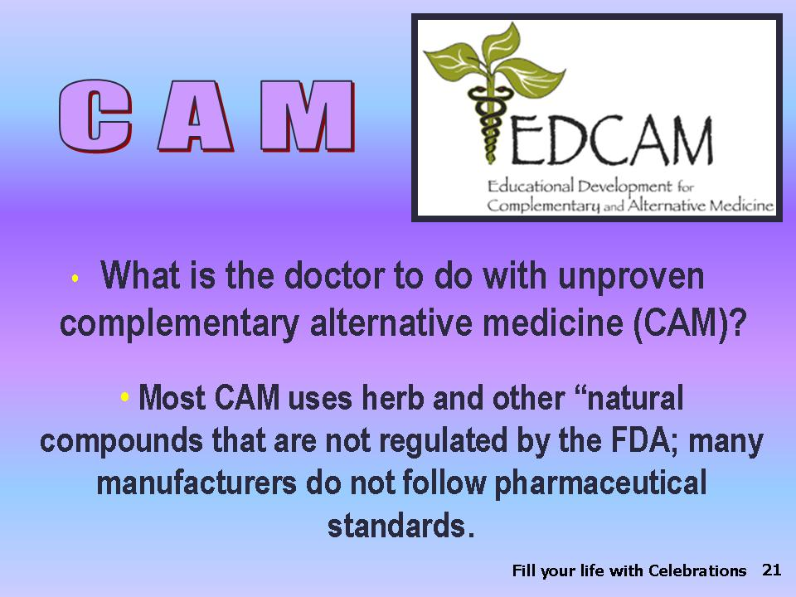 | *What is the doctor to do with unproven complementary alternative medicine (CAM)?  The problem with most CAM is that herb and other “natural” compounds are not regulated by the FDA; many manufacturers do not follow pharmaceutical standards or test for impurities and toxins. They often do not know how the untested compounds will interact with prescription medicine. Without large trials they cannot know the risks attendant upon their usage. There are very few CAM products that are tested by randomized, double-blind and controlled trials with humans that have matched standardized dosage with efficacy.
Slide 22 | 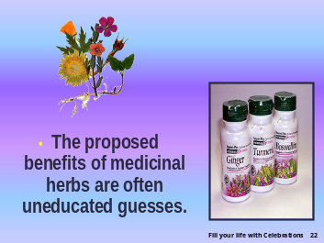 | *The proposed benefits of medicinal herbs are often uneducated guesses.
Slide 23 | 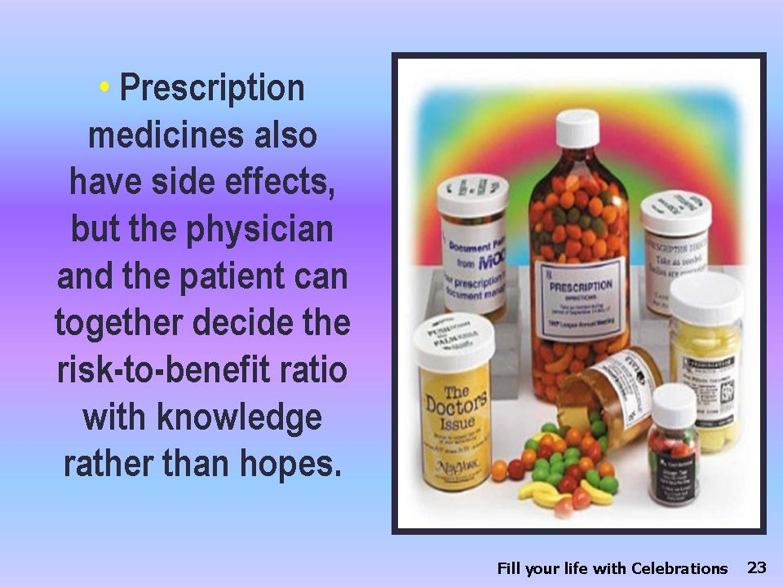 | Prescription medicines also have side effects, but the physician most often knows in advance about them, and the physician and the patient can together decide the risk-to-benefit ratio with knowledge rather than hopes.
Slide 24 | 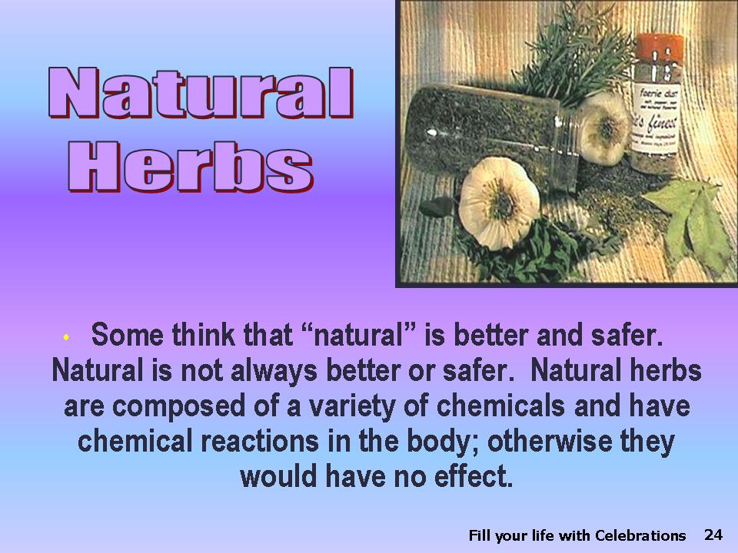 | *Some think that “natural” is better and safer. Natural is not always better or safer. Natural herbs, just like prescription medicines, are composed of a variety of chemicals and have chemical reactions in the body; otherwise they would have a no effect. Some over-the-counter non-regulated natural herbs and tonics have uncomfortable, dangerous, and sometimes deadly effects. This can also be true of regulated medicines, but there are two major differences.
Slide 25 | 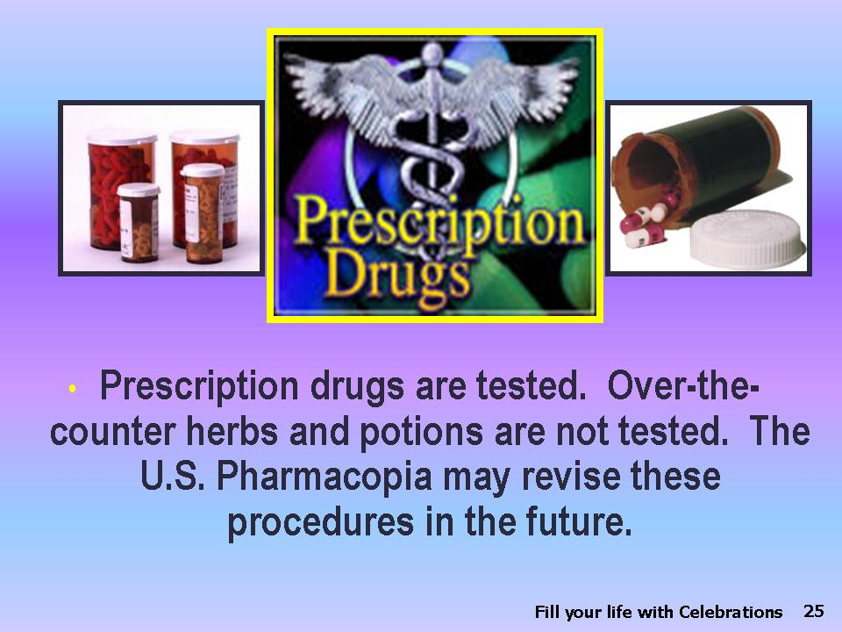 | *One: Prescription drugs are tested on animals and humans following strict guidelines set by the Food and Drug Administration (FDA). Over-the-counter herbs and potions are not tested at all or very little and are not regulated by the FDA. The U.S. Pharmacopia may tighten these procedures in the future.
Slide 26 | 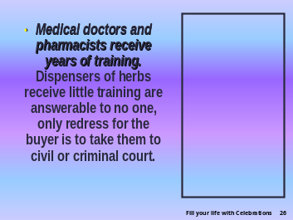 | *Two: Medical doctors and pharmacists receive years of training in their specialties and are licensed by the states and their own boards and are disciplined and monitored by these two regulatory bodies. Medical doctors’ practices and conduct are often reviewed by their peers.  Dispensers of herbs receive little training, are independent of all peer reviews, and are answerable to no one, and the only redress for the buyer is to take them to civil or criminal court
Slide 27 | 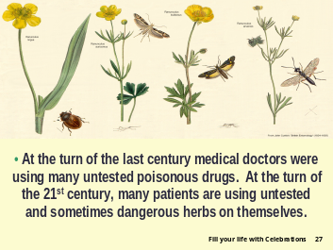 | *At the turn of the last century medical doctors were using many untested poisonous drugs, and the patients were suffering the consequences. At the turn of the 21st century, many patients are using untested and sometimes dangerous herbs on themselves and are pressuring the doctors to prescribe them.
Slide 28 | 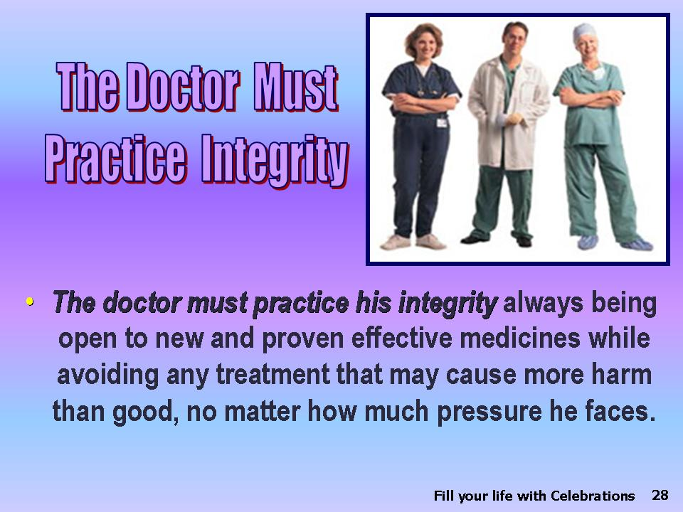 | *The doctor must practice his integrity by always being open to new and proven effective medicines while avoiding any treatment that may cause more harm than good, no matter how much pressure he faces.
Slide 29 |  | *Let the revolution begin with us. If we are dishonest with ourselves, how can we be honest with others? We need to be people of integrity! There is a spiritual and religious call for integrity. If we want to fill our lives with celebrations, we have to include integrity. Ask these questions:
Slide 30 |  | *Can I trust myself?  Can I trust you?  Can we be trusted?
Slide 31 | 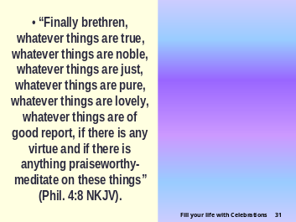 | We can if the following is our watchword: *“Finally brethren, whatever things are true, whatever things are noble, whatever things are just, whatever things are pure, whatever things are lovely, whatever things are of good report, if there is any virtue and if there is anything praiseworthy—meditate on these things” (Phil. 4:8, NKJV).  *Let us live a healthful lifestyle, which includes a personal life of integrity to our families, our communities, and ourselves
Slide 32 |  | *so that God can fill our lives with CELEBRATIONS.
Slide 33

National School Board Association USA.
? Newsweek, Dec. 9, 2002; pp. 67-74.
? Menopause, vol. 6, p. 7, 1999; vol. 7, p. 236, 2000.

