Slide 1 | 
Slide 2 |  | *T is for temperance, the temple of our purity.
Slide 3 | 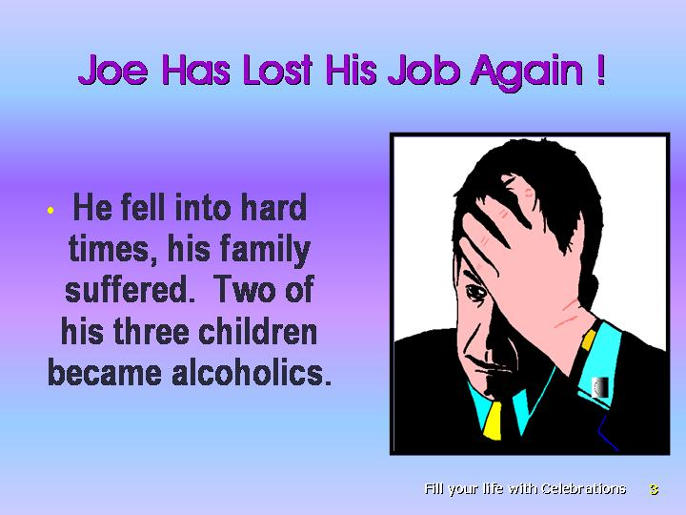 | *The children were whimpering; the wife was distraught and angry, not to say absolutely despondent! This was the twenty fifth job that Joe had lost—and this all through alcohol. He was dejected, never violent, and only a little argumentative sometimes when he was drunk. But the absenteeism and carelessness that crept into his job resulted in termination time and again.  Joe was well known in sporting circles. He was always ready and available to spend hours at the clubhouse drinking with friends who ultimately did not care to know him, as he fell into hard times because of his joblessness. Not only did the financial security of his family suffer, but also the future of his children: two of his three children became alcoholics themselves.
Slide 4 | 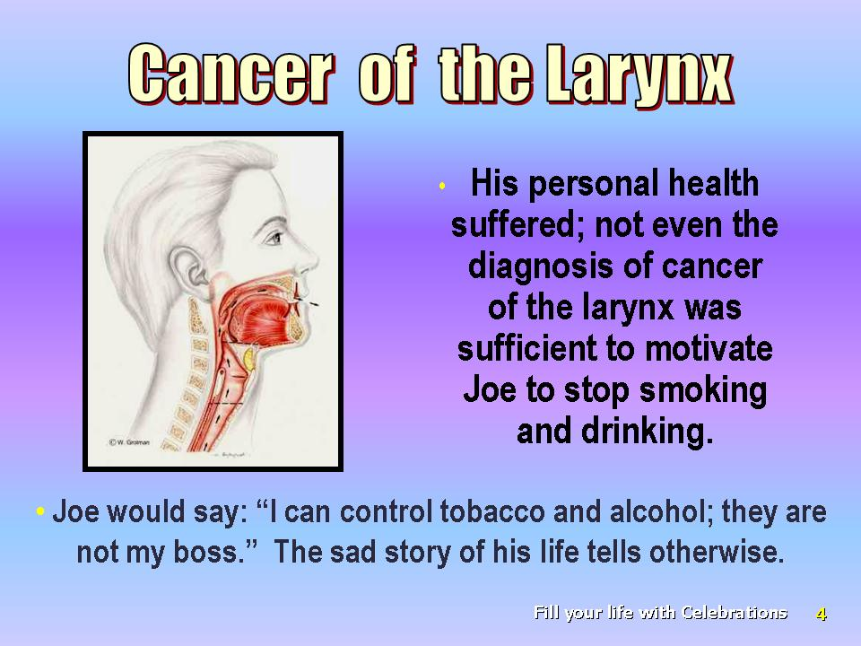 | *His personal health suffered; not even the diagnosis of cancer of the larynx was sufficient to motivate Joe to stop smoking and drinking. Whenever he was in recovery, which was ever only short-lived, Joe would say: “I can control tobacco and alcohol; they are not my boss.” The sad story of his life tells otherwise.  Many do not have an understanding of true temperance. To many, temperance is self-control or moderation.
Slide 5 | 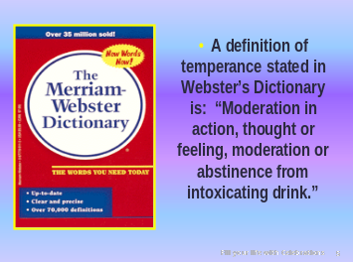 | *A definition of temperance stated in Webster’s Dictionary is. “Moderation in action, thought or feeling, or moderation or abstinence from intoxicating drink.”
Slide 6 | 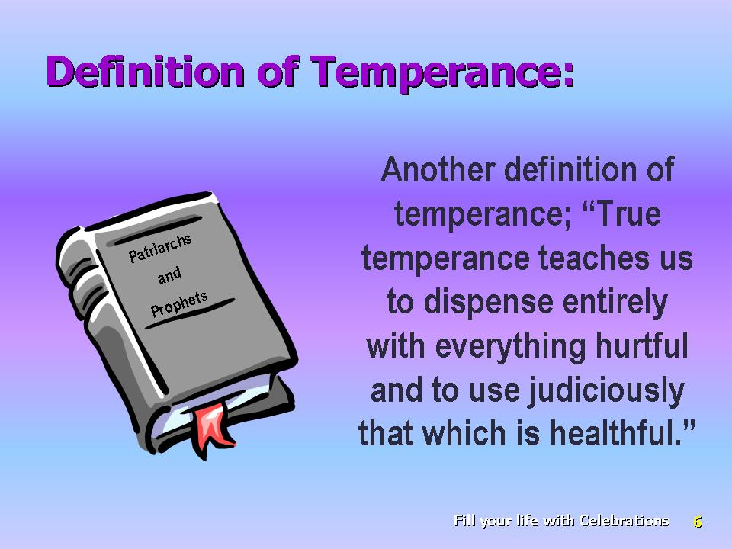 | *Another definition of temperance is, “True temperance teaches us to dispense entirely with everything hurtful and to use judiciously that which is healthful.”
Slide 7 | 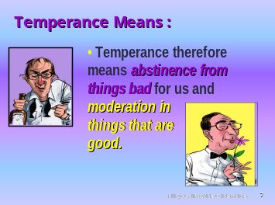 | *Temperance therefore means abstinence from things bad for us and moderation in things that are good. Is there any sense of moderation in the use of arsenic or strychnine? Definitely not! Some things are best totally avoided, things like tobacco alcohol and other dangerous addictive substances.
Slide 8 | 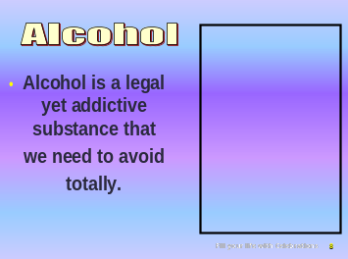 | *Alcohol is a legal yet addictive substance that we need to avoid totally.
Slide 9 | 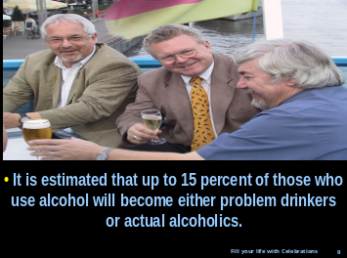 | *It is estimated that up to 15 percent of those who use alcohol will become either problem drinkers or actual alcoholics.
Slide 10 | 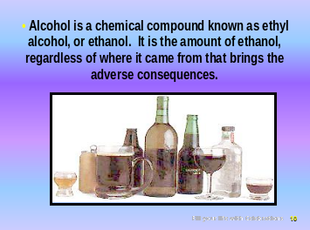 | *Alcohol is a chemical compound known as ethyl alcohol, or ethanol that can be consumed in a beverage. There is a common belief that wine and beer are not nearly as damaging as “hard liquor” and mixed drinks. However, it is the amount of ethanol, regardless of where it came from that brings the adverse consequences.
Slide 11 | 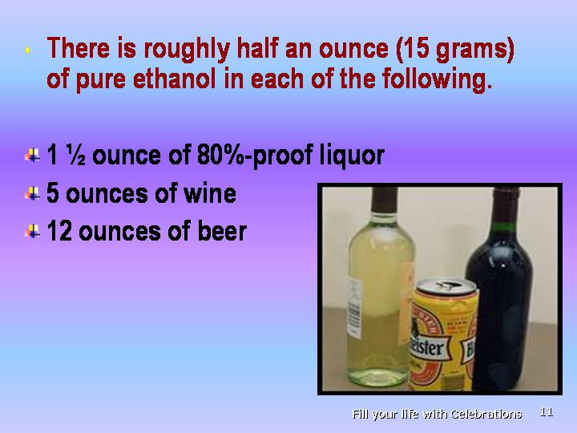 | *There is roughly half an ounce (15 grams) of pure ethanol in each of the following:  1½ ounce of 80%-proof liquor  5 ounces of wine  12 ounces of beer
Slide 12 | 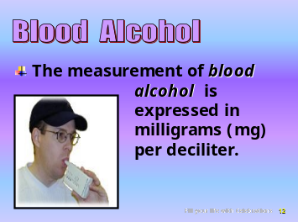 | *The measurement of blood alcohol is expressed in milligrams (mg) per deciliter (dl) of blood.
Slide 13 | 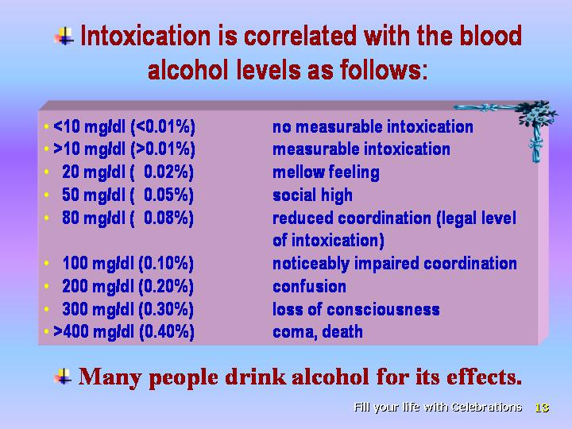 | Intoxication is correlated with the blood alcohol levels as follows:  — <10 mg/dl (< 0.01 %) no measurable intoxication  — >10 mg/dl (> 0.01 %) measurable intoxication  — 20 mg/dl ( 0.02 %) mellow feeling  — 50 mg/dl ( 0.05 %) social high  — 80 mg/dl ( 0.08 %) reduced coordination (legal level  of intoxication) — 100 mg/dl ( 0.10 %) noticeably impaired coordination  — 200 mg/dl ( 0.20 %) confusion  — 300 mg/dl ( 0.30 %) loss of consciousness  — >400 mg/dl ( 0.40 %) coma, death
Slide  14 | 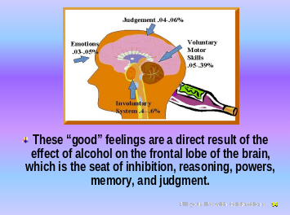 | *Many people drink alcohol for its effects. These are a relaxation of the body, a loss of inhibitions, and an easing of aches and pains. These “good” feelings are a direct result of the “blocking” effect of alcohol on the frontal lobe of the brain, which is the seat of inhibition, reasoning, powers, memory, and judgement. As brain messages slow down, tensions seem to float away, and a person experiences a “relaxed” feeling. That is why it is called the “social lubricant.”
Slide 15 | 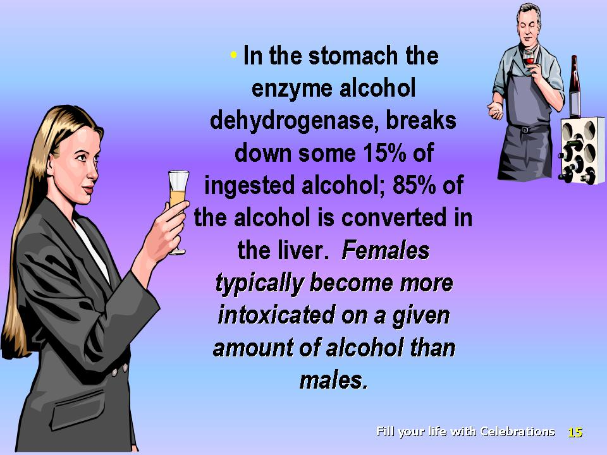 | *In the stomach the enzyme alcohol dehydrogenase, breaks down some 15% of ingested alcohol. The remaining 85 percent of the alcohol is converted in the liver. Females have less alcohol dehydrogenase than men; as a result, when a boy and a girl of the same weight are given equal amounts of alcohol, the girl will have a higher blood alcohol level than the boy. Females typically become more intoxicated on a given amount of alcohol than males.
Slide 16 | 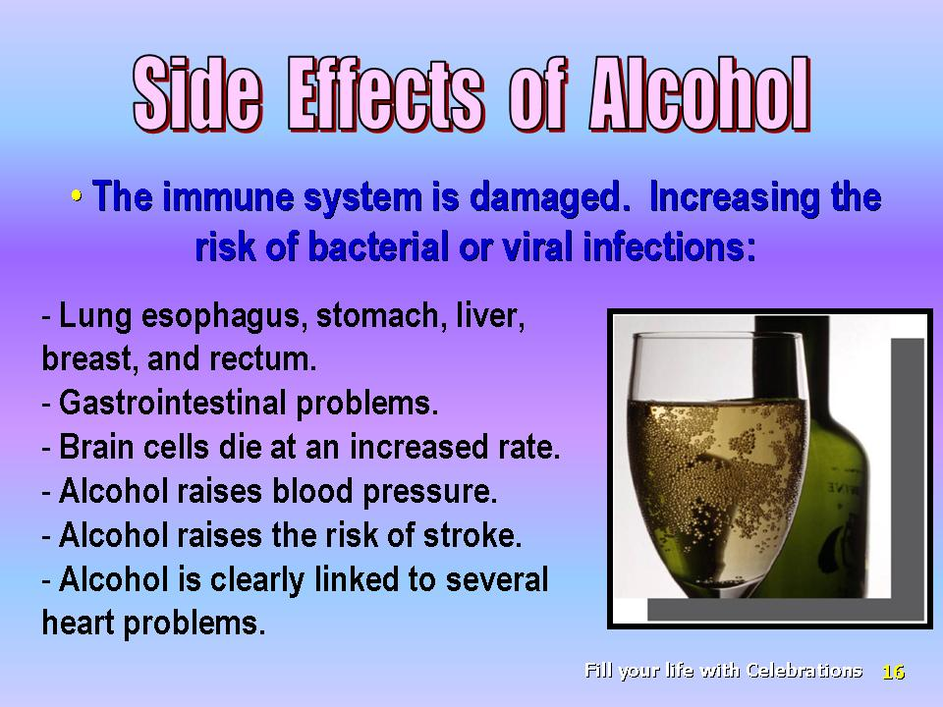 | *There are many side effects of alcohol consumption relating to the physical, emotional as well as social life.  • The immune system is damaged even by the social use of alcohol in the so called "moderate drinker," increasing the risk of bacterial or viral infections:  a. it takes only two drinks to reduce antibody production of the B-lymphocytes by 67 percent.  b. it weakens the NK cells thus increasing the risk for cancers of the mouth, larynx, lung esophagus, stomach, liver, breast, and rectum.  c. it impairs the function of the polymorphonuclear leucocyte (measurable effects are detected at 0.05% blood alcohol, the level below that of legal intoxication). As the amount of alcohol ingestion rises, the ability of polymorphonuclear leucocyts to go to the infection site, as well as their ability to ingest invaders becomes progressively impaired. The more alcohol present, the greater the impairment.  • Gastrointestinal problem,,, (fatty liver, alcoholic hepatitis, cirrhosis, esophageal varices, pancreatitis, gastritis).  • Alcohol causes brain cells to die at an increased rate (alcoholic cerebellar degeneration and also cerebral dysfunction in the long term).  • Alcohol raises blood pressure (women seem to be more susceptible due to their relative lack of the enzyme alcohol dehydrogenase. As little as two or three drinks per day increases the risk of hypertension by 40 percent in women).  • Alcohol raises the risk of stroke (the famous Honolulu Heart Study found that even the so called light drinkers of as little as one to fourteen ounces per month have more than twice the risk of having one of these hemorrhagic strokes).  • Alcohol is clearly linked to several heart problems even though it is widely proclaimed that it is good for the heart (the high rate of sudden death among heavy alcohol users is likely due in part to dangerous heart rhythm disturbances; 20 to 30 percent of all cardiomyopathy in the U.S. is due to alcohol alone.)
Slide 17 | 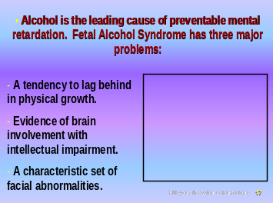 | 1. *Alcohol is the leading cause of preventable mental retardation.  Fetal Alcohol Syndrome has three major sets of problems:  a. a tendency to lag behind in physical growth both in the womb and after birth;  b. evidence of brain involvement with such problems as intellectual impairment, hyperactivity, distractibility, and impulsiveness;  c. a characteristic set of facial abnormalities including small eye openings, a small head circumference, a thin upper lip, skin folds at the corners of their eyes and a low nasal bridge.
Slide 18 | 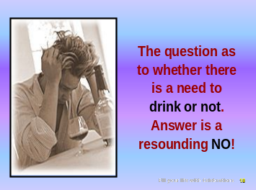 | *There are many other problems related to alcohol. These help answer *the question as to whether there is a need to drink or not. The answer is a resounding no!
Slide 19 | 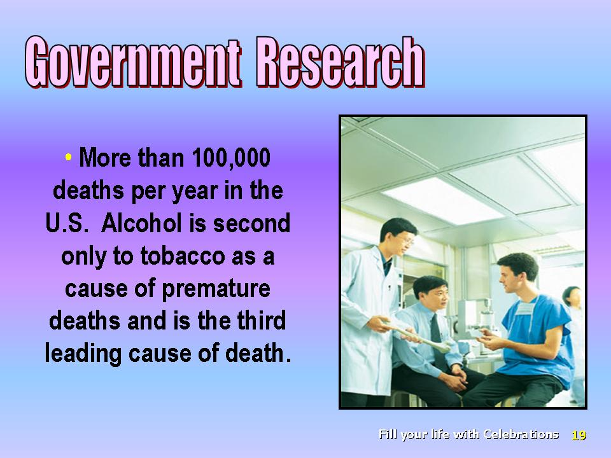 | *Government research reveals that alcohol causes more than 100,000 deaths per year in the U.S. Thus among drugs, alcohol is second only to tobacco as a cause of premature deaths in this nation and is the third leading cause of death.
Slide 20 | 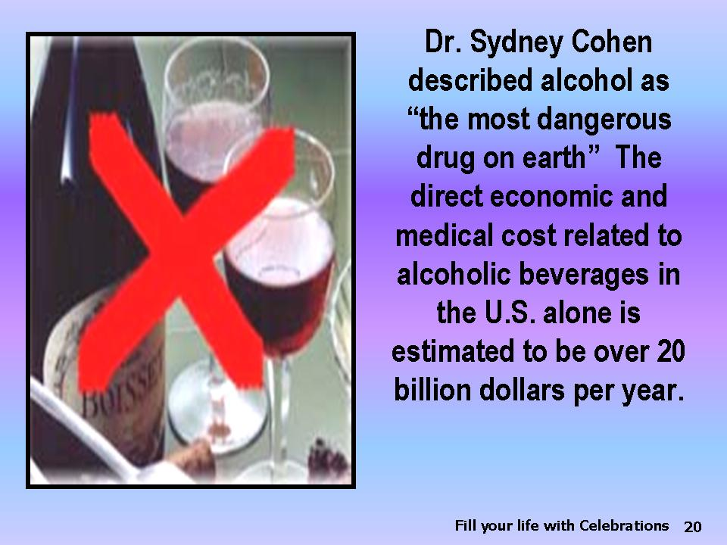 | *Dr. Sydney Cohen, a drug abuse expert, described alcohol as “the most dangerous drug on earth” The direct economic and medical cost of alcoholic beverage abuse in the U.S. alone is estimated to be over 20 billion dollars per year. Absenteeism in the U.S. government due to alcohol beverage abuse is estimated to cost in excess of half a billion dollars per year. The inestimable social cost is expressed in suffering, despair, illness and death.
Slide 21 | 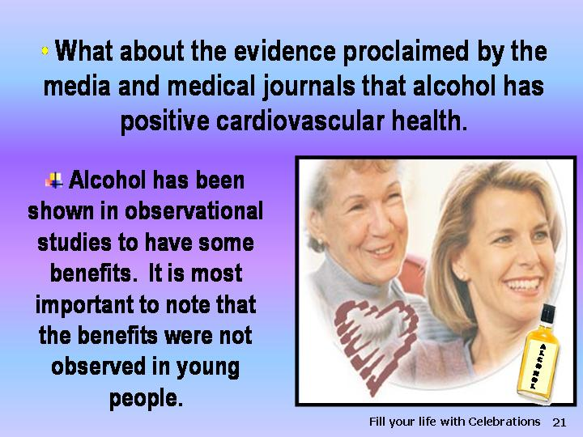 | *What about the evidence proclaimed by the media and medical journals that alcohol has positive cardiovascular health benefits to those who use it? It is generally accepted that alcohol is the mediator of some of these observed benefits, though there are additional benefits from the flavinoids and other substances present also in unfermented grape juice. *Alcohol has been shown in observational studies to have some benefits. It is most important to note that the benefits were not observed in young people.
Slide 22 | 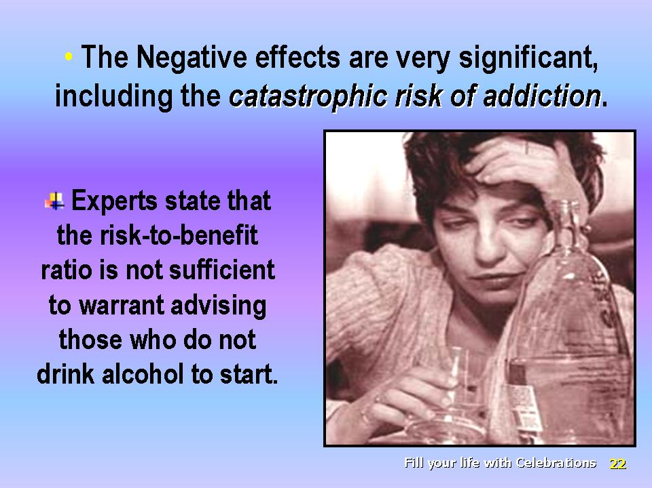 | *The negative effects of alcohol are so significant, including the catastrophic risk of addiction, that experts do not recommend it. The editorials associated with the publication of such studies state that the risk-to-benefit ratio is not sufficient to warrant advising those who do not drink alcohol to start!,
Slide 23 | 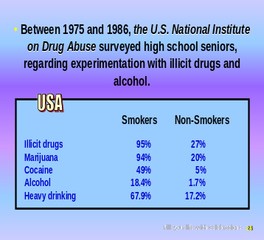 | *Between 1975 and 1986, the U.S. National Institute on Drug Abuse surveyed high school seniors to see how many of these students had experimented with illicit drugs and alcohol. The result showed a great difference between the student smokers and non-smokers in their experimentation with mind-altering drugs:  Smokers Non-Smokers  Illicit drugs 95 % 27 %  Marijuana 94 % 20 %  Cocaine 49 % 5 %  Alcohol 18.4 % 1.7 %  Heavy drinking 67.9 % 17.2 %
Slide 24 | 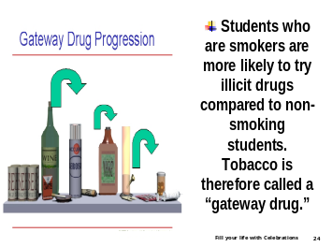 | *This survey indicates that students who are smokers are more likely to try illicit drugs compared to non-smoking students. Tobacco is therefore called a “gateway drug.”
Slide 25 | 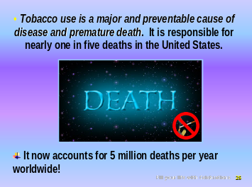 | *Tobacco use is a major and preventable cause of disease and premature death. It is responsible for nearly one in five deaths in the United States. It accounted for an estimated 430,700 premature deaths each year from 1990 to 1994 and more than US$53 billion in direct medical costs in 1993., It now accounts for 5 million deaths per year worldwide!
Slide 26 | 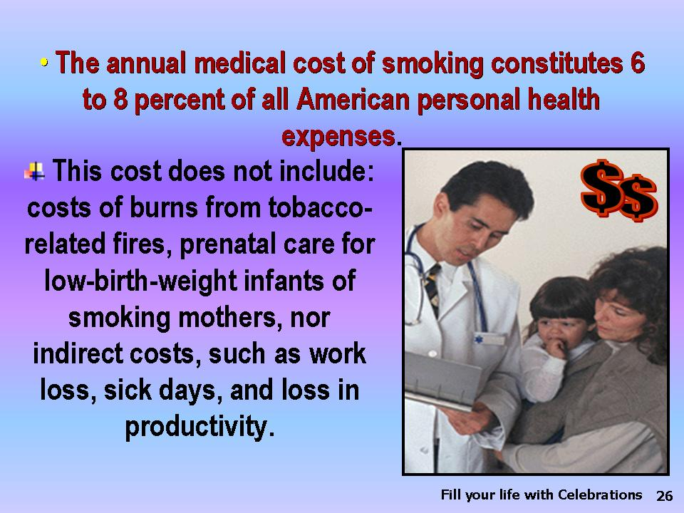 | *The annual medical costs of smoking constitute 6 to 8 percent of all American personal health expenses; this figure is expected to increase to as much as 12 percent over the next few years. These costs may be under estimated, since related costs associated with environmental smoke were not included. Neither were the costs of burns from tobacco-related fires, prenatal care for low-birth-weight infants of smoking mothers, nor indirect costs, such as work loss, sick days, and loss in productivity.
Slide 27 | 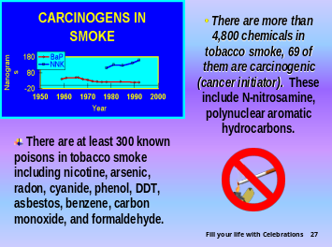 | *There are more than 4,800 chemicals in tobacco smoke, at least 69 of them are carcinogenic (cancer initiator). These include N-nitrosamine, polynuclear aromatic hydrocarbons, and other carcinogenic agents. There are at least 300 known poisons in tobacco smoke including nicotine, arsenic, radon, cyanide, phenol, DDT, asbestos, benzene, carbon monoxide, and formaldehyde.
Slide 28 | 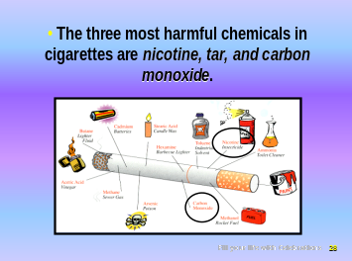 | *The three most harmful chemicals in cigarettes are nicotine, tar, and carbon monoxide.
Slide 29 | 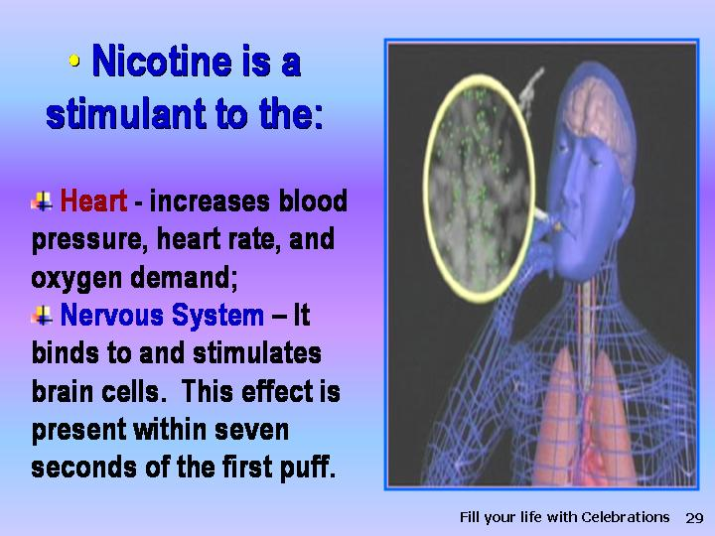 | *Nicotine is a stimulant to the:  • heart (by releasing catecholamines, which increase blood pressure, heart rate, and oxygen demand);  • nervous system (it binds to and stimulates brain cells, via the central nicotinic cholinergic receptors. This effect is present within seven seconds of the first puff).
Slide 30 | 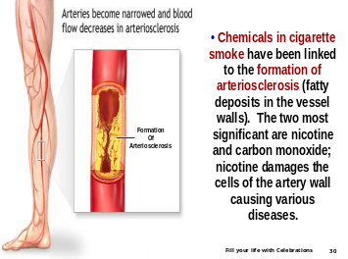 | *A number of chemicals in cigarette smoke have been linked to the formation of atherosclerosis (fatty deposits in the vessel walls). The two most significant components are nicotine and carbon monoxide; nicotine damages the cells of the artery wall, allowing fatty substances from the blood to leak into the underlying tissues and start the process of atherosclerosis. This latter pathology is involved in causing various diseases and is greatly accelerated by smoking.
Slide 31 | 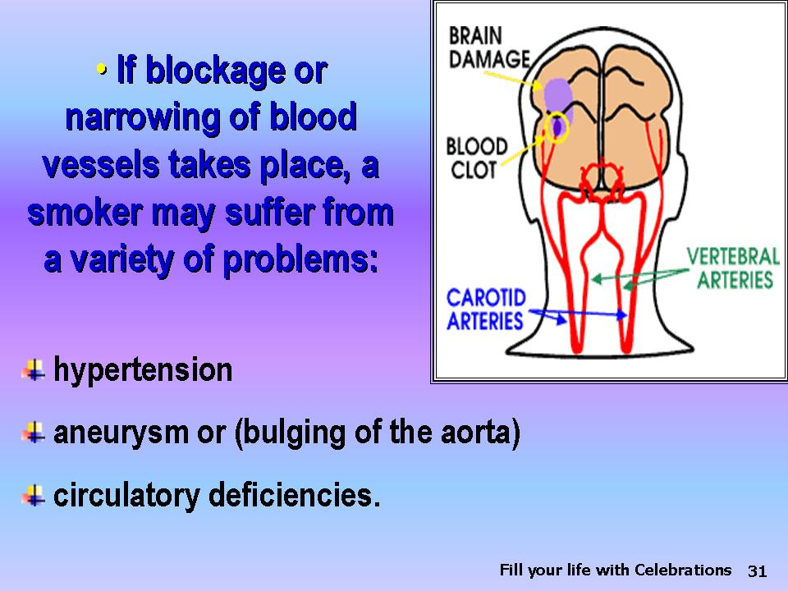 | *If blockage or narrowing of blood vessels takes place, a smoker may suffer from a variety of problems: hypertension, which is an elevation of blood pressure; aneurysm or bulging of the aorta (the major blood vessel transporting blood from the heart to the rest of the body); and circulatory deficiencies.
Slide 32 | 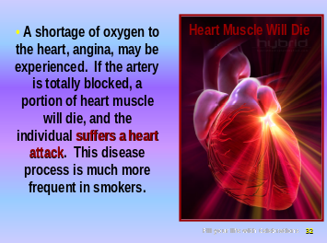 | *The individual will suffer from a shortage of oxygen to the heart; pain, called angina, may be experienced. Should the artery become totally blocked, a section of the heart is deprived of blood, a portion of heart muscle will die, and the individual suffers from a heart attack This disease process is much more frequent in smokers.
Slide 33 | 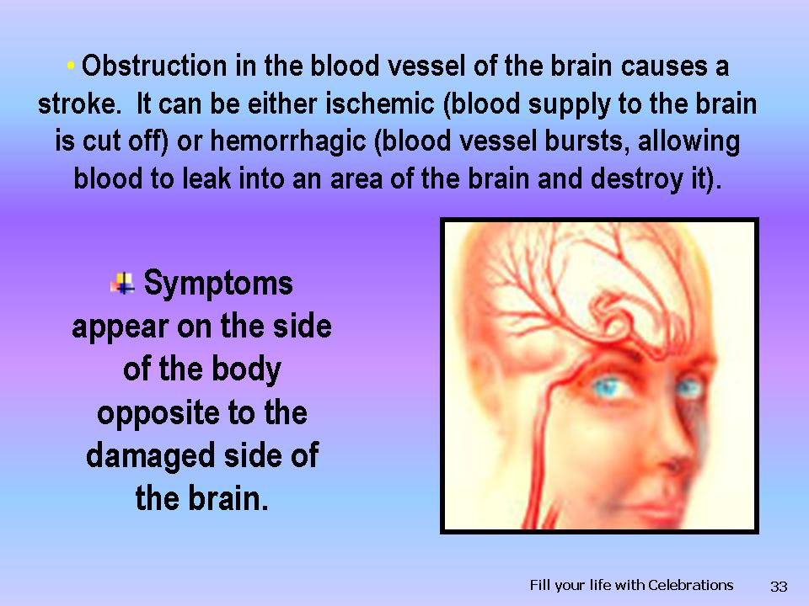 | *If obstruction takes place in the blood vessel of the brain, then the patient may suffer a stroke. It can be either ischemic (blood supply to the brain is cut off) or hemorrhagic (blood vessel bursts, preventing a normal flow and allowing blood to leak into an area of the brain and destroy it). Because nerves in the brain cross over to the opposite side of the body, symptoms appear on the side of the body opposite the damaged side of the brain.
Slide 34 | 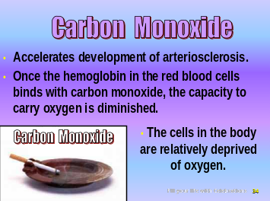 | *Carbon monoxide (CO) accelerates the development of atherosclerosis; it also has other widespread damaging effects. Once the hemoglobin in the red blood cells binds with carbon monoxide, the capacity to carry oxygen is diminished. All the cells in the body, including those of a fetus (when present), are relatively deprived of oxygen.
Slide 35 | 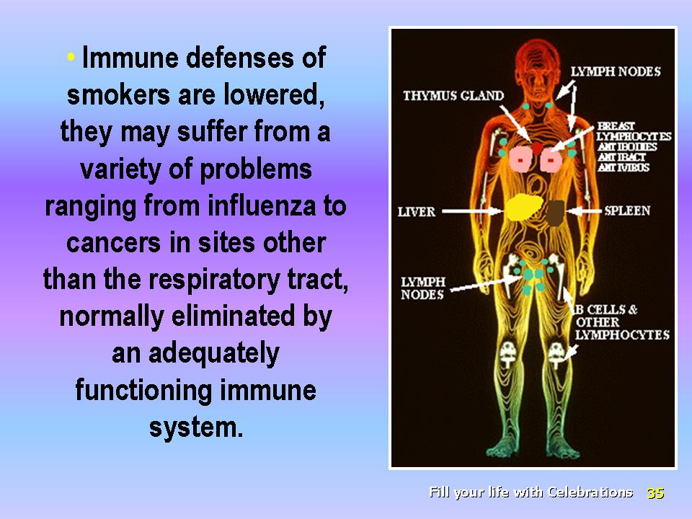 | *The immune defenses of smokers are lowered, and they may suffer from a variety of problems ranging from influenza to cancers in sites other than the respiratory tract that would normally be eliminated by an adequately functioning immune system.
Slide 36 | 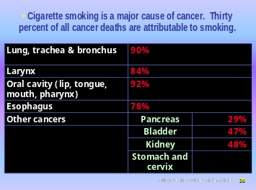 | * Cigarette smoking is a major cause of cancer. Thirty percent of all cancer deaths are attributable to smoking:  • lung, trachea, and bronchus (90 percent);  • larynx (84 percent)  • oral cavity (lip, tongue, mouth, pharynx) (92 percent); and  • esophagus (78 percent).
Slide 37 | 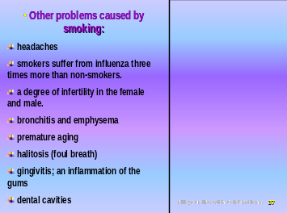 | *Cigarette smoking is a contributing factor for several other cancers. There are many other problems caused by smoking, such as:  • Headaches, may be the result of carbon monoxide as well as decreased  cerebral blood flow to the brain.  • Smokers suffer from influenza three times more than non-smokers because of lowered immunity and inactivation of local protective mechanism.  • Smoking causes a degree of infertility in the female as the male.  • bronchitis and emphysema;  • premature aging;  • halitosis (foul breath) unresponsive to mouthwash and toothpaste;  • gingivitis; an inflammation of the gums resulting in a three-fold greater loss of teeth than that of non-smokers; and  • dental cavities, three times more common in smokers because of  increased plaque, bacterial growth, and decay.
Slide 38 | 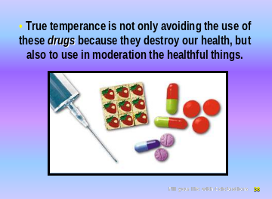 | *True temperance is not only avoiding the use of these drugs because they destroy our health but also to use in moderation the healthful things, such as:
Slide 39 | 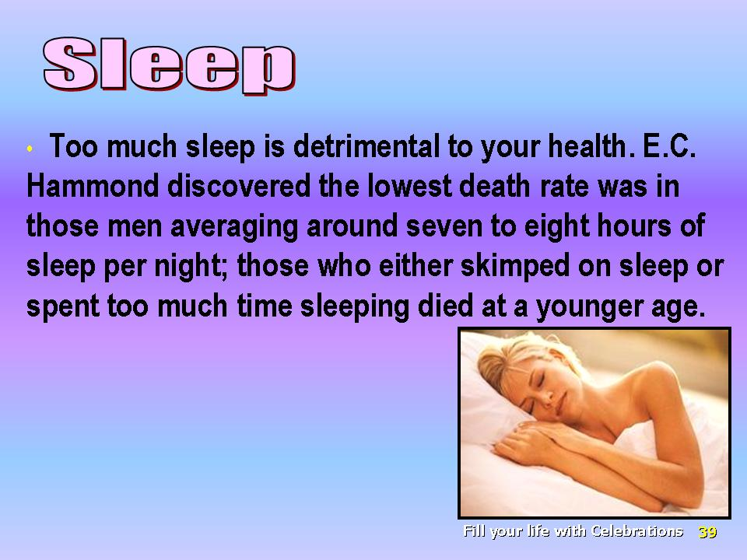 | *Sleep. Too much sleep is detrimental to your health. E.C. Hammond discovered the lowest death rate was in those men averaging around seven to eight hours of sleep per night, whereas those who either skimped on their sleep or spent too much time sleeping in bed, died at a younger age than those who got the proper amount of sleep on a regular basis.
Slide 40 | 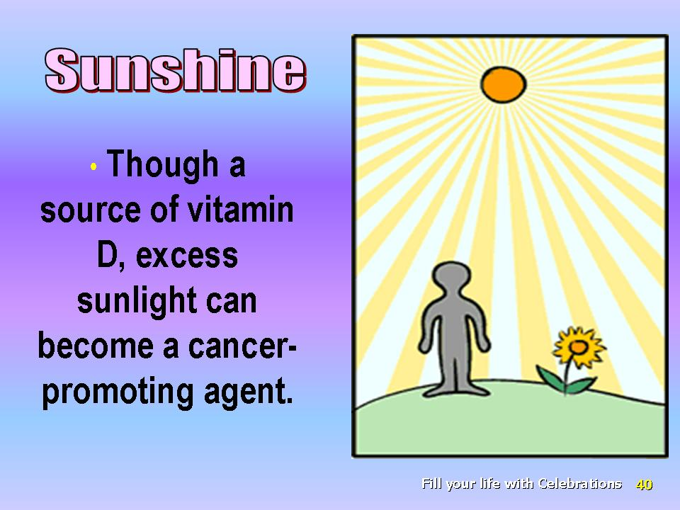 | *Sunshine. Though a source of vitamin D, in excess sunlight can become a cancer promoting agent.
Slide 41 | 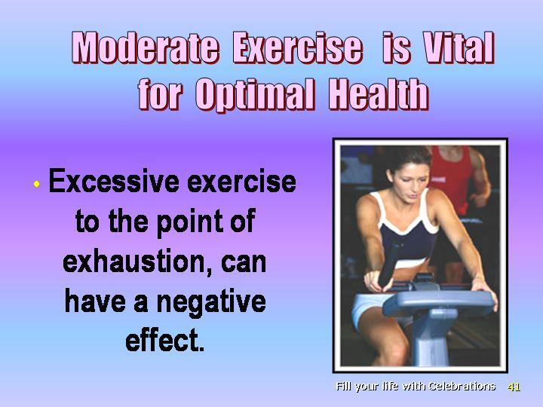 | *Moderate exercise is vital for optimal health, however, excessive exercise to the point of exhaustion, which is seen typically in some athletes, can have a negative effect.
Slide 42 |  | *Sexual activity, though a God-given gift, is often abused.
Slide 43 | 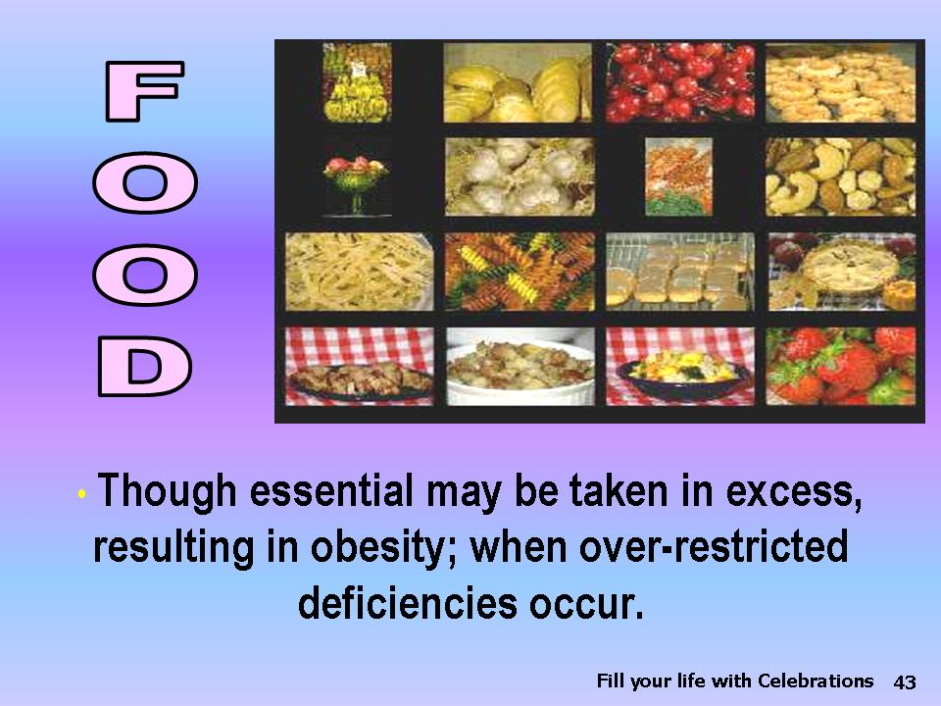 | *Food, though essential, may be taken in excess, resulting in obesity or even restricted in such a manner as to result in deficiencies.
Slide 44 | 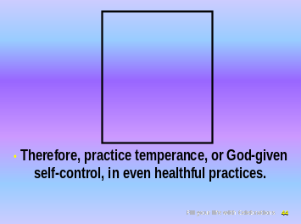 | *Therefore, practice temperance, or God-given self-control, in even healthful practices.
Slide 45 | 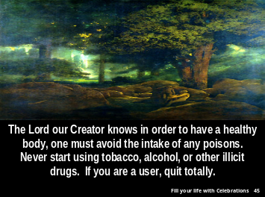 | *The Lord our Creator knows that in order to have a healthy body, one must avoid the intake of any poison. Never start using tobacco, alcohol, or other illicit drugs. If you are a user, quit totally.
Slide 46 |  | *The Bible gives the secret of successfully living a drug-free life, “Let this mind be in you, which was also in Christ Jesus” (Phil. 2:5, NKJV).
Slide  47 | 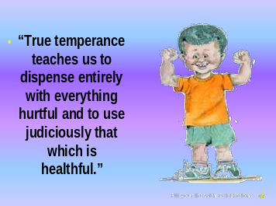 | ٠ “True temperance teaches us to dispense entirely with everything hurtful and to use judiciously that which is healthful.”
Slide 48 |  | *God has promised to give us success in all things, including that of a healthful lifestyle. “I can do all things through Christ who strengthens me” (Phil. 4:13, NKJV).
Slide 49 |  | * God can fill our lives with CELEBRATIONS!
Slide 50 | 

Patriarchs and Prophets, p. 562.
? U.S. Dept. of Health and Human Services. Alcohol. In: The Surgeon General’s Report on Nutrition and Health. 1988. Public Health Service DHHS (PHS) Publication Number 88-50210, p. 633.
? Aldo-Benson, M, et al. Federation of American Sciences for Experimental Biology, Annual Meeting May, 1988. (Abstract # 7966).
? U.S. Department of Health and Human Service. “Effects of alcohol on Health and Body Systems.” In Eight Special Report to the US Congress on alcohol on Health. National institutes of Health (NIH) Publication No. 94-3699, Sep 1993 p.177-178.
Glassman AB, Bennet CE, Randall CL. “Effects of ethyl alcohol on human peripheral lymphocytes.” Arch Pathol Lab Med 1985 Jun;109(6):540-542.
? MacGregor RR. “Alcohol and immune defense.” JAMA 1986 Sep 19;256(11):1474-1479.
? Isselacher KJ, Braunwald E, et al, editors. Harrison’s Principles of Internal Medicine – 13th edition (CDROM version). (New York, McGraw Hill, Inc. Health Professions Divisions, 1994).
? Kelly WN, DeVita VT, JR, et al., editors. Textbook of Internal Medicine - 2nd edition. (Philadelphia: JP. Lippencott Company, 19920).
? Diamant NE. “Disease of the Esophagus.” In Kelly WN, DeVita VT, JR, et al., editors. Textbook of Internal Medicin-2nd edition. (Philadelphia: JP. Lippencott Company, 1992) pp. 452-454.
? Witteman JC,Willett WC, et al. “ Relation of moderate alcohol consumption and risk of systemic hypertention in women.” J Cardiol 1990 Mar 1;65(9):633-637.
? Donahue RP, Abott RD, et al. Alcohol and hemorrhagic stroke. “The Honolulu Heart Program.” JAMA 1986 May 2;255(17):2311-2314.
? U.S. Department of Health and Human Service. “Effects of alcohol on Health and Body Systems .” In: Eighth Special Report to the US Congress on Alcohol and Health. National institutes of Health (NIH) Publication No. 94-3699, Sep 1993 p.174-175.
? Ibid., p.174.
? US Department of Health and Human Services. “Effects of Alcohol on Fetal and Postnatal Development.” In: Eighth Special Report to the US Congress on Alcohol and Health. National Institutes of Health (NIH) Publication No. 94-3699, Sep 1993 p. 221.
? Rice DP. “The economic cost of alcohol abuse and alcohol dependence: 1990.” Alcohol Health & Research World 1993; 17(1):10-11.
? McGinni JM, Foege WH. “Actual causes of death in the United States,” JAMA 1993 Nov 10;270(18):2207-2212.
? Goldberg IJ, “To drink or not to drink?” New England Journal of Medicine, 348;163, January 9, 2003.
? Wallerath T, Poleo D, Huige, Li, et al., “Red wine increases the expression of human endothelial nitric oxide synthase,” Journal of the American College of Cardiology, volume 41, number 3, pages 471-478.
? McGinni JM, Foege WH. “Actual causes of death in the United States,” JAMA 1993;270:2207-2212.
? Centers for Disease Control and Prevention. “Smoking-attributable mortality and years of potential life lost—United States, 1984,” Morb Mortal Wkly Rep. 1997;46:444-51.
? . Miller VP, Ernst C, Collin F. “Smoking-attributable medical care cost in the USA,”Soc Sci Med. 1999;48:375-91.
? Warner KE, Hodgson TA, Carrol CE. “Medical costs of smoking in the United States: estimates, their validity, and their implications,” Tobacco Control. 1999; 8:290-300.
? Bartlett JC, Miller LS, Rice DP, Wax WB. Centers for Disease Control and Prevention, “Medical-care expenditures attributable to cigarette smoking,” United States, 1993, MMWR. 1994:44:469-472.
? Tobacco use in the USA CDC 2002.
? U.S. Preventive Service Task force. Counseling to Prevent Tobacco Use, In: Guide to Clinical Preventive Services (Baltimore: Williams and Wilkens, 1996), pp. 597-509.
? Prevention and US Department of Health and Human Services. Reducing the Health Consequences of Smoking: 25 Years of Progress. A Report of the Surgeon General. (Atlanta: US Department of Health and Human Services, Public Health Service, Centers for Disease Control and Prevention, Center for Chronic Disease Health Promotion, Office on smoking and Health, 1989).
? Hammond EC. “Some preliminary findings on physical complaints from a prospective study of 1,064,004 men and women,” AM J Pub Health. 54:11, 1964.
? Nieman DC. “Exercise Immunology: practical applications,” Int J Sports Med 1997 Mar;18 Suppl 1:S91-100.
? Patriarchs and Prophets, p. 562.

