Slide 1 | 
Slide 2 | 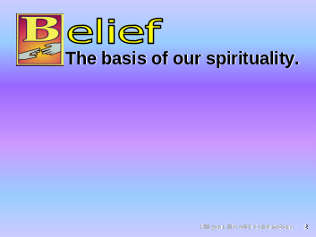 | *B is for belief, the basis of our spirituality.
Slide 3 | 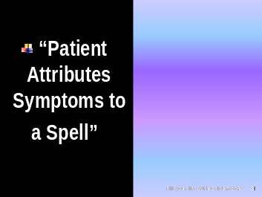 | A physician who was having a light day at the office became a little playful. His patient was again complaining of a myriad of symptoms, unrelated to any known syndrome or disease complex. The patient expressed concerns that an evil spell had been cast on him and was making him ill.
Slide 4 | 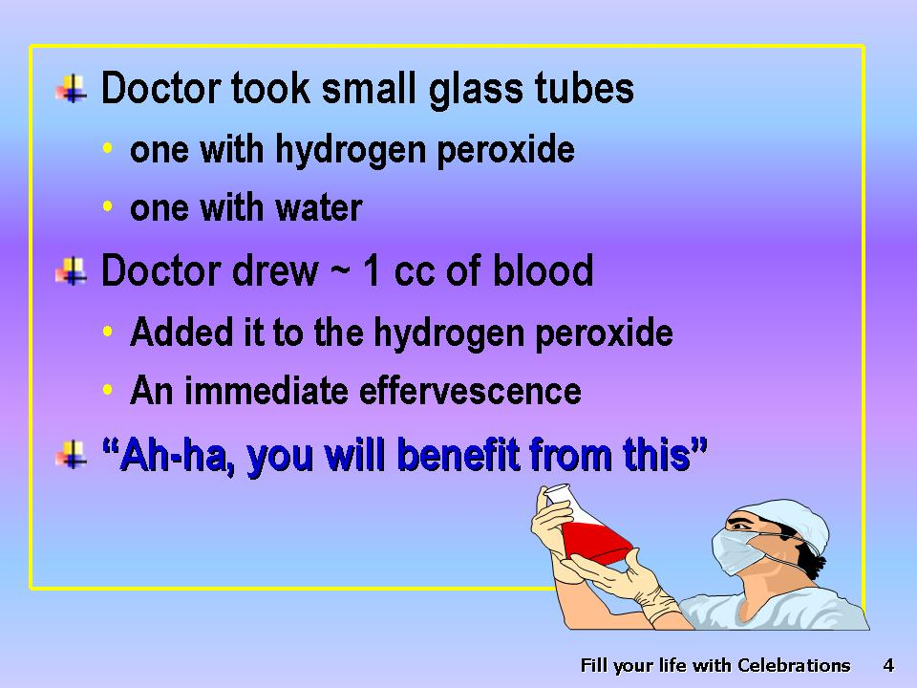 | *So the doctor took two small *glass tubes and placed hydrogen peroxide in one and water in the other. The patient did not know the two liquids were different. Then the physician drew a couple of cc’s of blood and dribbled it into the hydrogen peroxide. Naturally there was an immediate effervescence and the doctor knowingly nodded. “Ah-ha, you will benefit from this,” and gave a saline injection.
Slide 5 |  | *After a short time the patient was recalled from the waiting room. A second sample was drawn and dribbled into the plain water. It mixed without any reaction. The evil spell was pronounced broken, and the patient left feeling immensely better.
Slide 6 |  | *What a classic demonstration of the placebo effect!  Feeling and believing he was cured, he told his experience to many of his friends.
Slide 7 | 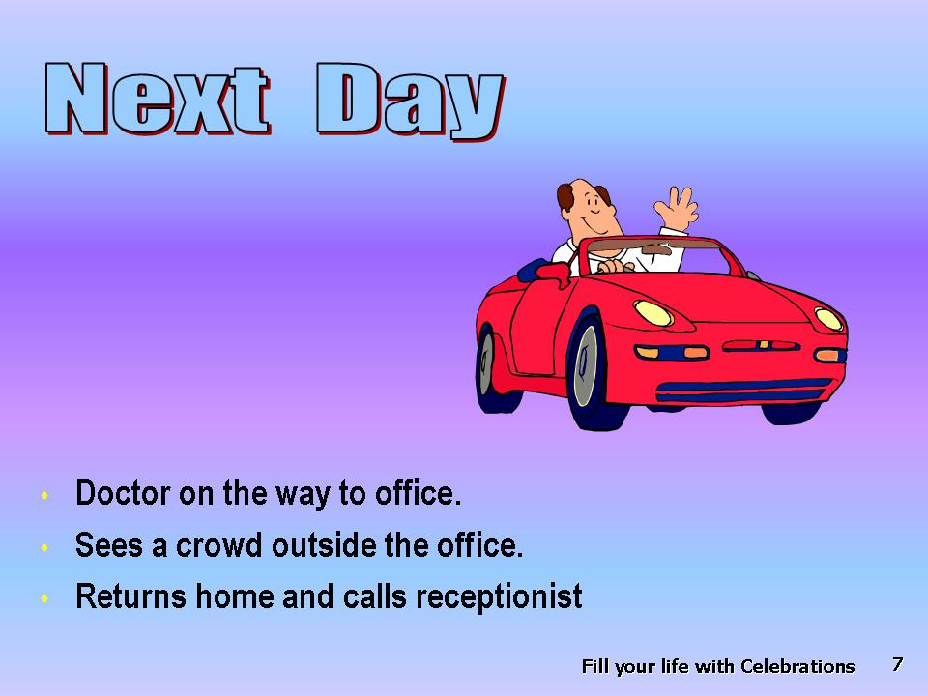 | *The next day the doctor driving to his office saw it was thronged with people. He wisely went home and called the receptionist.
Slide 8 | 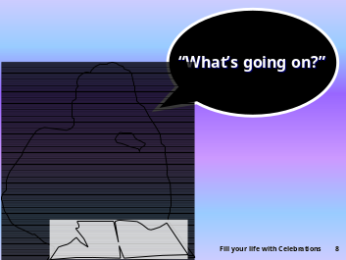 | * “What’s going on?” he asked.
Slide 9 | 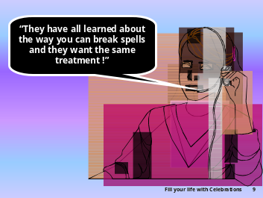 | * “They have all learned about the way you can break evil spells, and they want the same treatment!”
Slide 10 | 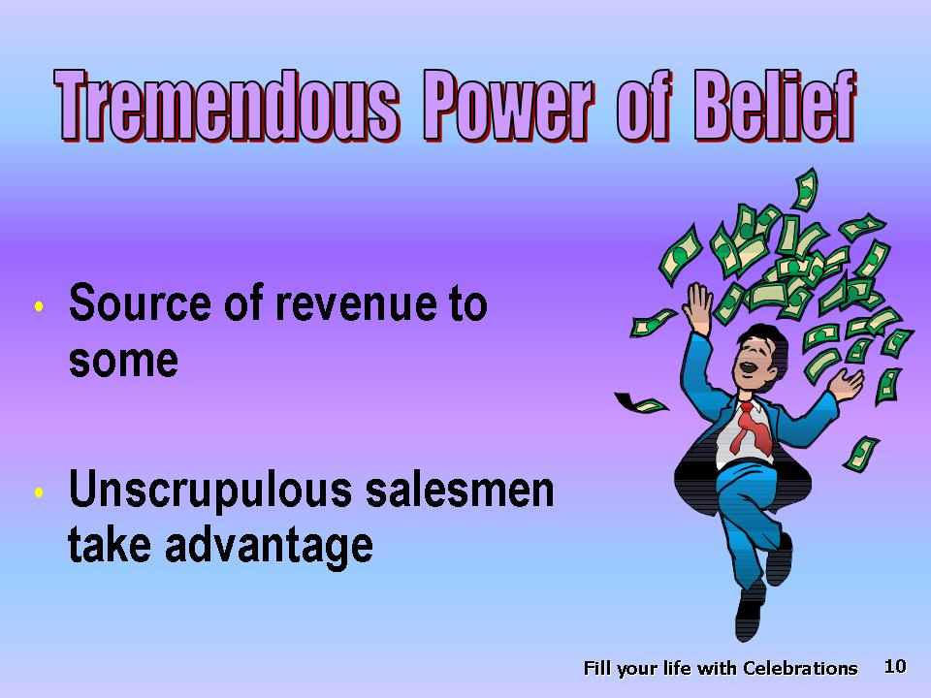 | *This experience illustrates the tremendous power of belief, the ability of self-conviction. For many a peddler of “quack medicine,” this phenomenon is a mighty source of revenue. Many “unscrupulous” salespersons create a false need in the minds of their targets.
Slide 11 | 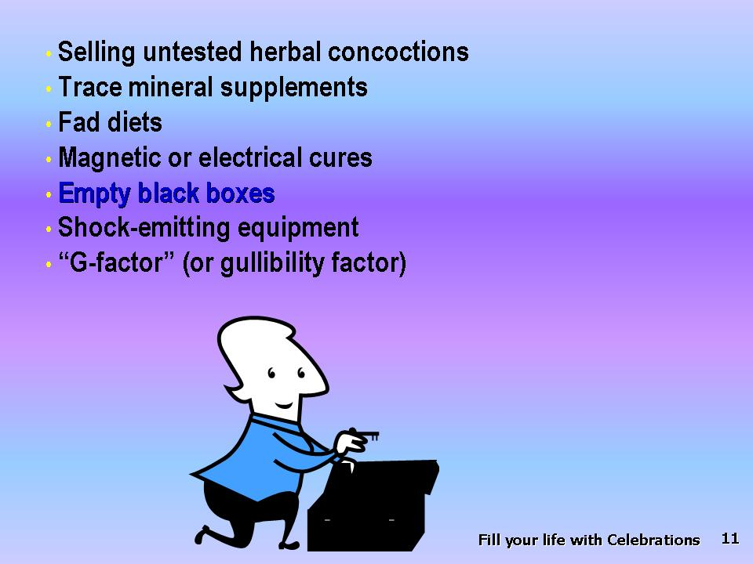 | They then sell *untested herbal concoctions, nonessential mineral supplements, special diets, magnetic or electrical cures mediated through empty black boxes or mild shock-emitting equipment. They are trading on what can be called the “G-factor”— the gullibility factor. To the healthy, the only cost is some money from which they are soon parted. In a situation in which cancer is involved, sometimes the delay leads to a fatal outcome or to the wasting of limited and precious resources on worthless “panaceas.”
Slide 12 | 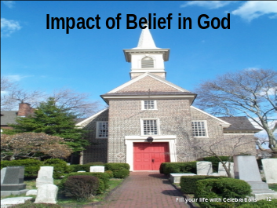 | *It is important to place our belief and trust in that which is reliable!
Slide 13 |  | *Belief or faith in a religious setting has been shown to have statistically significant benefits that exceed the placebo effect.
Slide 14 | 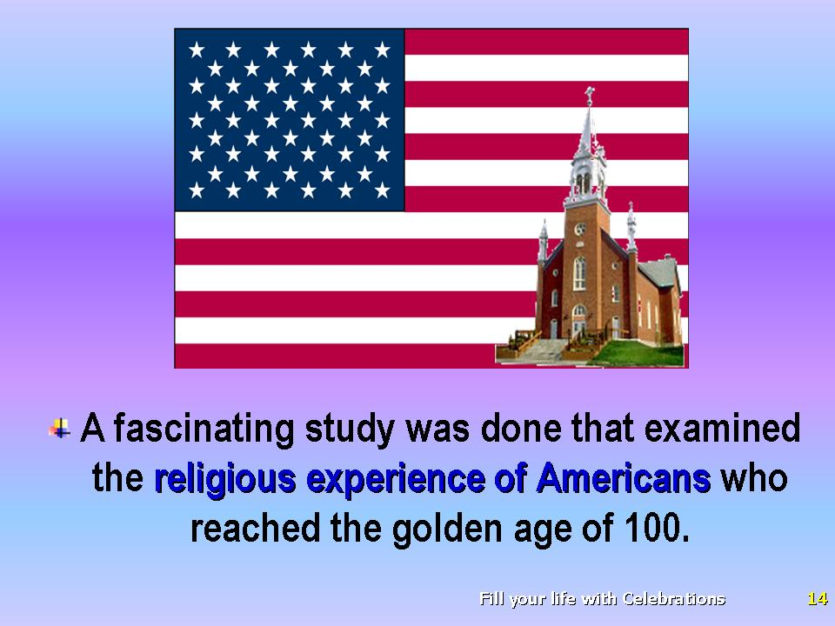 | *A fascinating study was made that examined the religious experience of Americans who reached the golden age of 100.
Slide 15 | 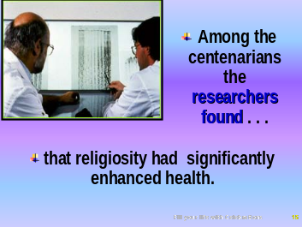 | *Among the centenarians the researchers found that religiosity had significantly enhanced health.
Slide 16 | 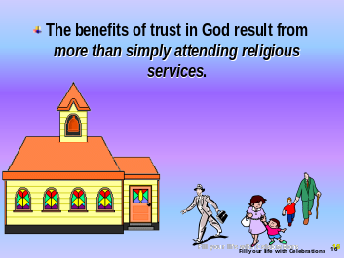 | Although there are still many unanswered questions, the benefits of trust in God result from more than simply attending religious services.
Slide 17 | 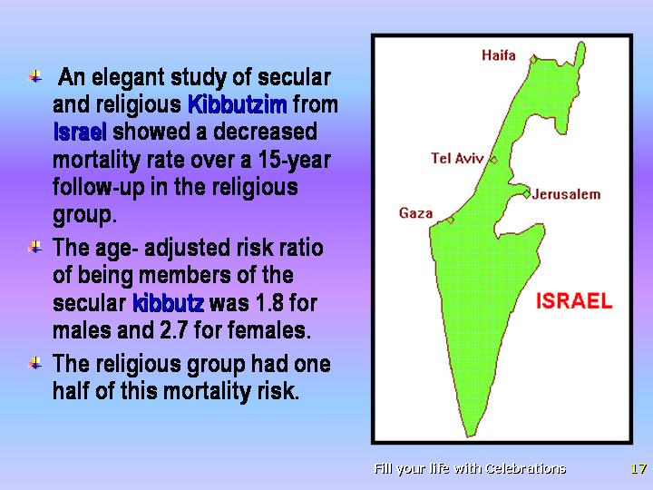 | *An elegant study of secular and religious kibbutzim from Israel showed quite clearly a decreased mortality rate over a 15-year follow-up in the religious group. The age-adjusted risk ratio of being members of the secular kibbutz was 1.8 for males and 2.7 for females. The religious group had one half of this mortality risk.  It is interesting that the far-reaching benefits of faith transcend age and racial boundaries. *recent study of African Americans found that those who engaged in organized religious activities had improved health and life satisfaction. Similarly, C.G. Ellison writing in Social Science and Medicine found that a lack of religious affiliation increases the risk of depression in African Americans.  A connection between social relationships and survival has been documented in several studies. V.J. Schoenbach, et al. have documented this effect particularly among white males.
Slide  18 | 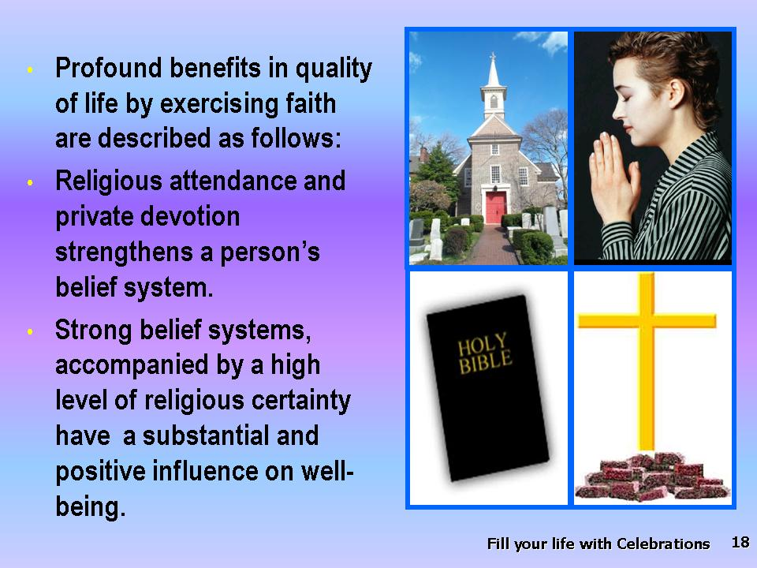 | *One of the most consistent findings across all racial groups is that spirituality profoundly improves the quality of life. The profound benefits in the quality of life brought about by *exercising faith are described by a Duke University researcher as follows:  · *Religious attendance and private devotion strengthens a person’s religious belief system.  · Strong religious systems, in turn, when accompanied by a high level of religious certainty, have a substantial and positive influence on well-being.
Slide 19 | 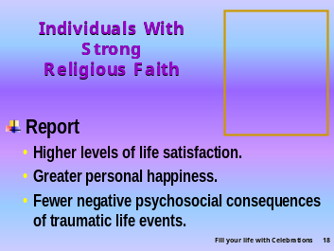 | · *Individuals with strong religious faith report higher levels of life satisfaction, greater personal happiness, and fewer negative psychosocial consequences of traumatic life events.
Slide 20 | 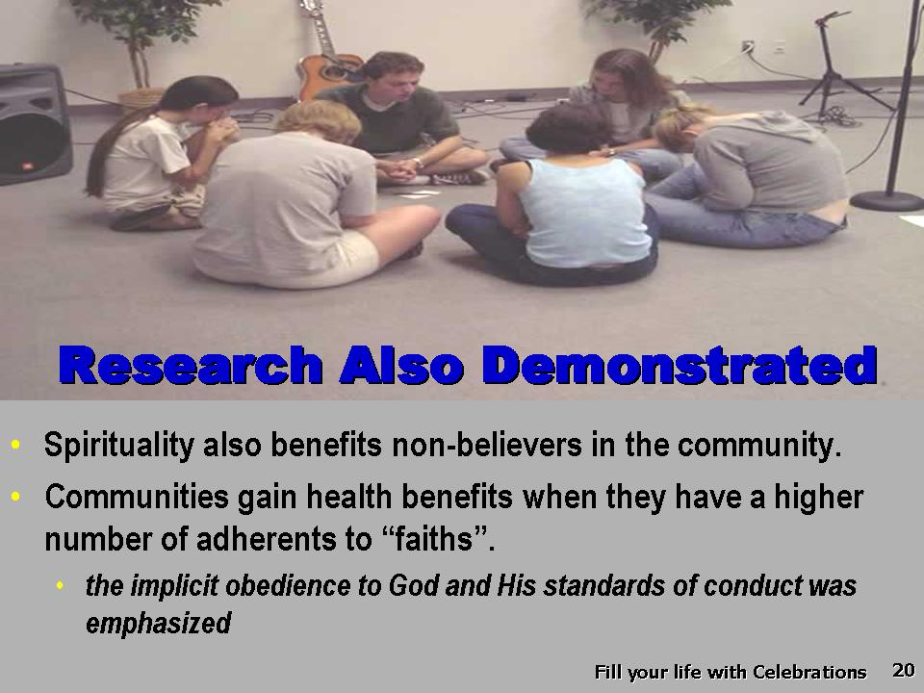 | *Another amazing aspect of spirituality is that it not only helps believers but also benefits the nonbelievers in their community. Research has demonstrated that communities gain health benefits when they have higher numbers of adherents to faiths that emphasize implicit obedience to God and His standards of conduct.
Slide 21 | 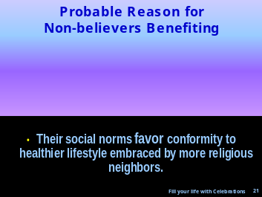 | *Probably the reason that nonbelievers are benefitted as well is that their social norms favor conformity to the more healthful lifestyle embraced by their more religious neighbors.
Slide 22 | 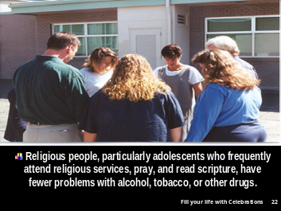 | *Religious people, particularly adolescents from religious homes who frequently attend religious services, pray, and read scripture, have fewer problems with alcohol, tobacco, or other drugs than do their nonreligious peers.
Slide 23 |  | *Researchers also found that religion was positively associated with emotionally healthful values and socially accepted behavior, such as tutoring or other volunteer activity often promoted by their religious organization.  Harold G. Koenig, M.D. discusses the findings of Idler and Kasl. These reporters noted a connection between healthier emotional lives and closer social ties in religiously active people, which often resulted in lower levels of disability. The increased physical activity associated with leisure and social activities did not fully account for the increased benefits in these people’s lifestyle, and the authors concluded, “A significant effect of religiousness remains even after social activities have been considered.” We see that belief in a loving God is a very positive and powerful health-promoting state of mind.
Slide 24 | 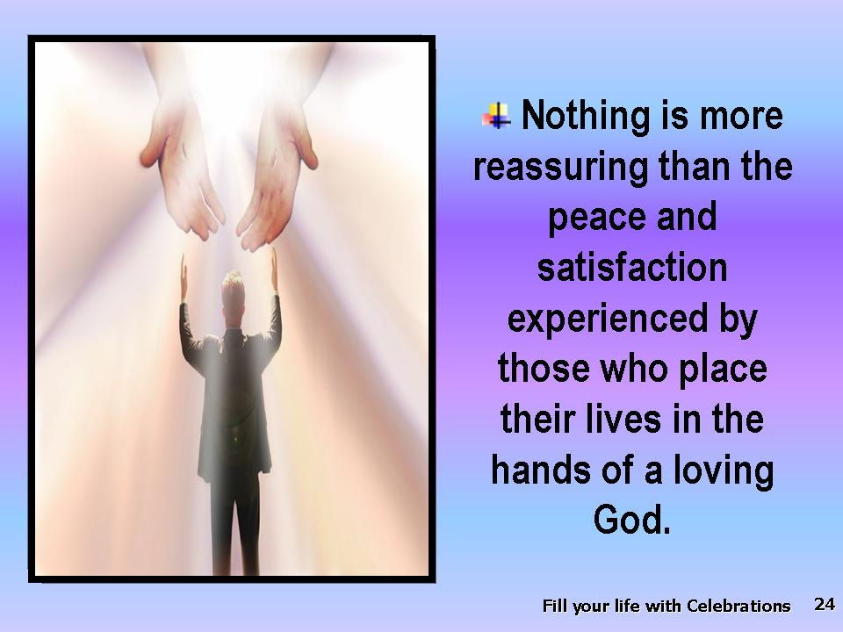 | *There is nothing more reassuring than the peace and satisfaction experienced by those who place their lives in the hands of a loving God and who are aware of His love for them. This brings health, happiness, and a sense of purpose. A belief in God may be associated with reduction in stress, depression, and loneliness.
Slide 25 | 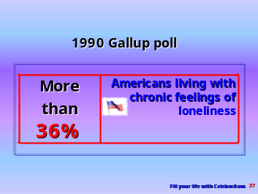 | *A 1990 Gallup poll revealed that more than 36 percent of Americans live with chronic feelings of loneliness.
Slide 26 | 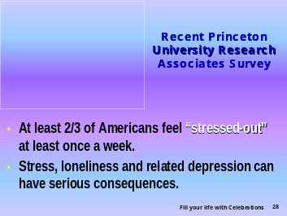 | *According to a Princeton University Research Associates survey, at least two-thirds of Americans feel stressed-out at least once a week. Stress, loneliness, and related depression can have serious consequences.
Slide 27 | 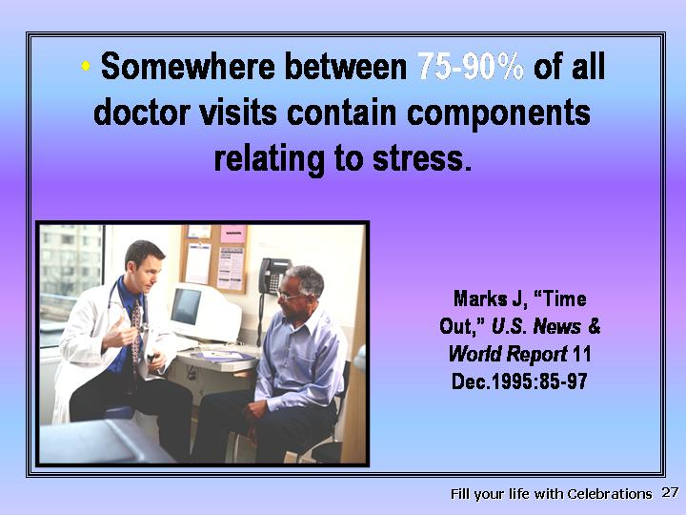 | *Somewhere between 75 and 90 percent of all doctor visits contain components relating to stress.
Slide 28 | 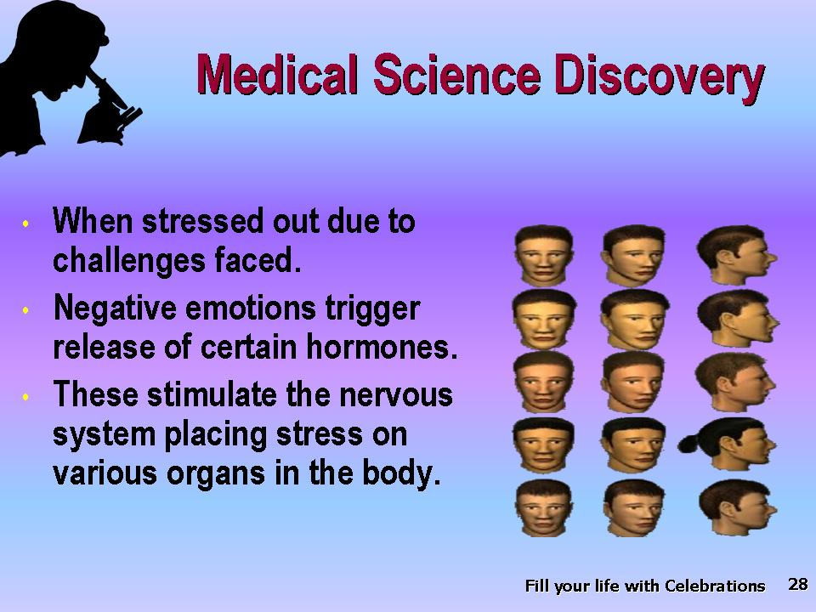 | *Medical science has discovered that when you feel stressed out from facing challenges, the negative emotions trigger the release of certain hormones and stimulate the nervous system in such a way as to put stress on the *various organs of the body.
Slide 29 | 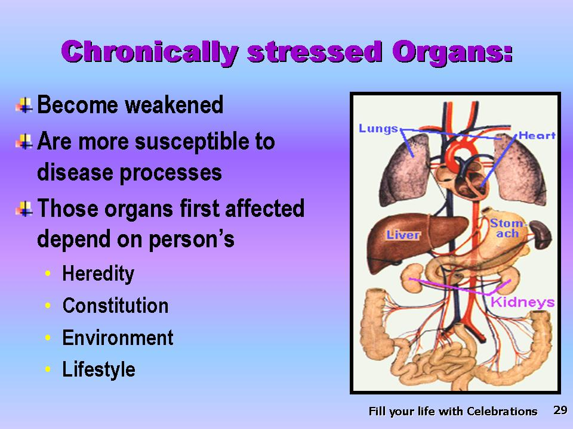 | *If these organs are subjected to stress over long periods of time, they become weakened. Once weakened, they are more susceptible to a variety of disease processes. The order and intensity with which organs are affected depend upon the person’s heredity, constitution, environment, and lifestyle. For example:
Slide 30 | 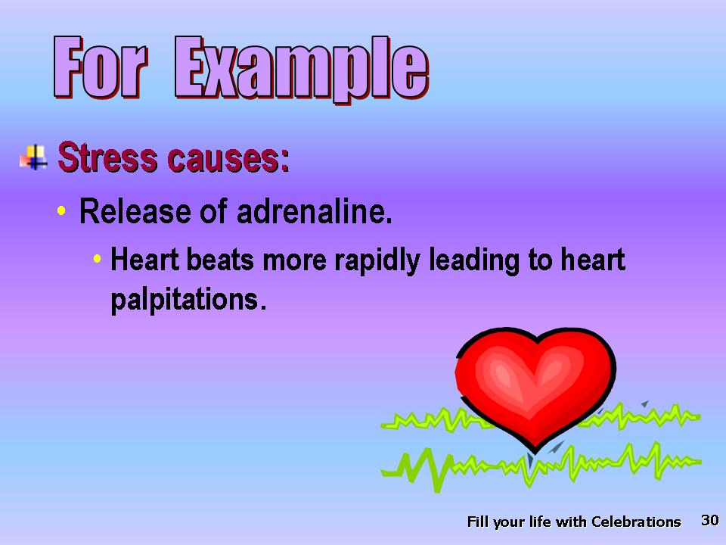 | *Stress may cause the release of adrenaline, making the heart beat more rapidly and powerfully. Such stress may cause one to suffer from heart palpitations (unpleasant awareness of heartbeat).
Slide 31 | 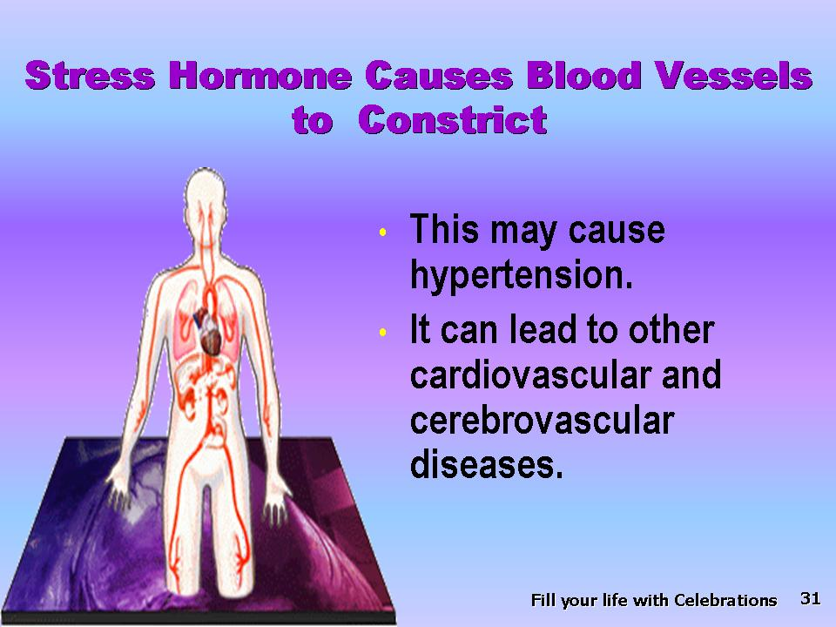 | *When stress hormones cause the blood vessels to constrict, they may augment the effects of hypertension and
Slide 32 | 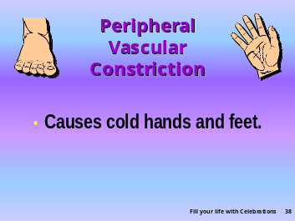 | cause diminished peripheral vascular flow, leading to cold hands and feet.
Slide  33 | 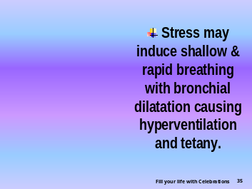 | *Stress may induce shallow and rapid breathing with bronchial dilation, which causes hyperventilation and tetany.
Slide 34 | 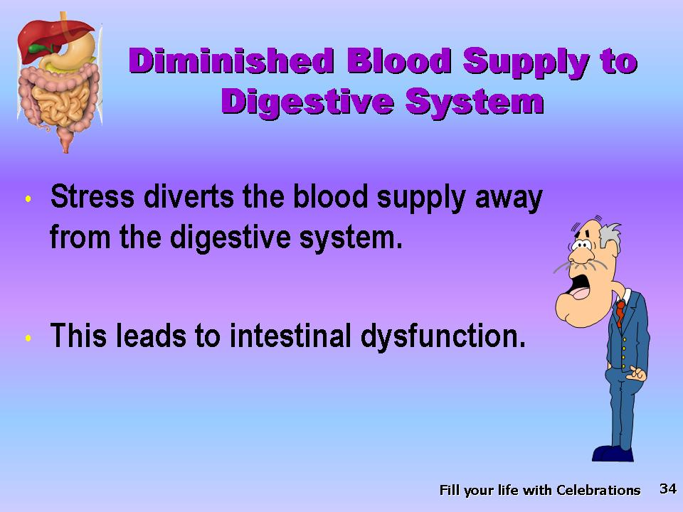 | *Stress results in diversion of the blood supply away from the digestive system, possibly affecting digestive processes.
Slide 35 | 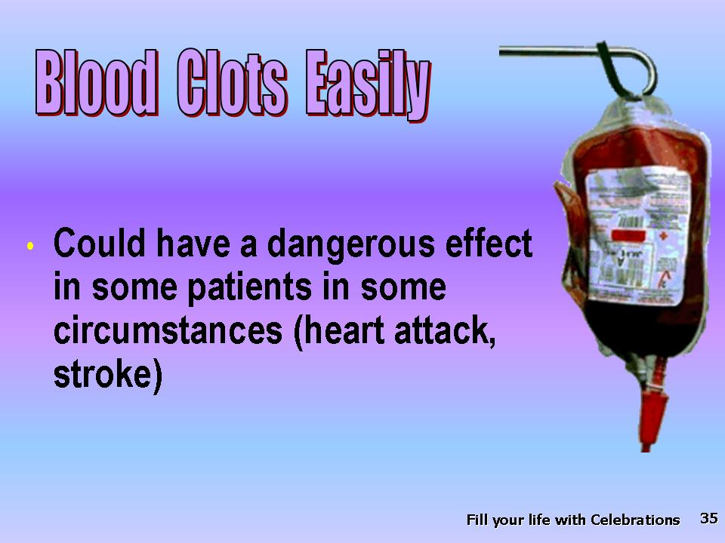 | *Stress induces a state of increased coagulability (clotting) of the blood which though protective in some circumstances, could have deleterious effects in others.
Slide 36 | 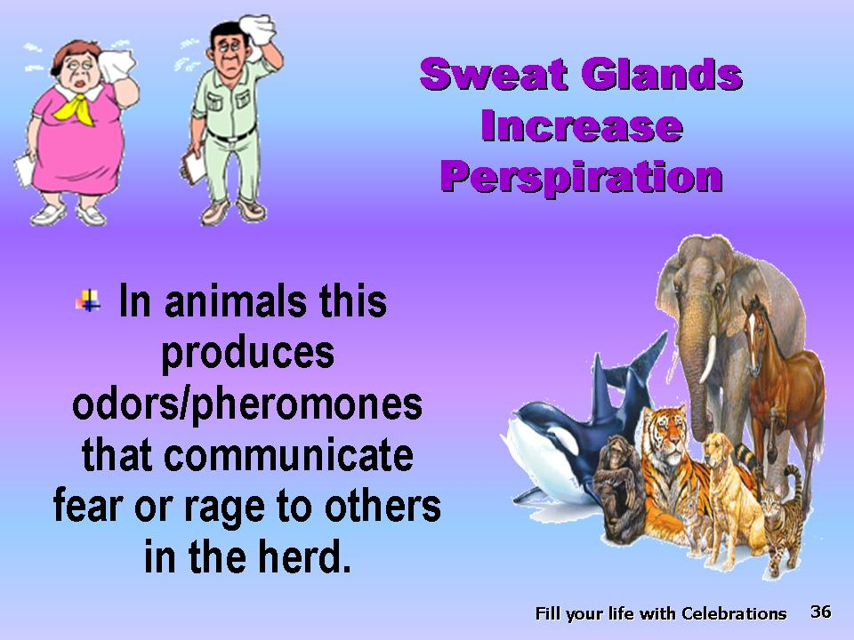 | *Chronic stressful conditions may increase perspiration, leading to unpleasant dampness.
Slide 37 | 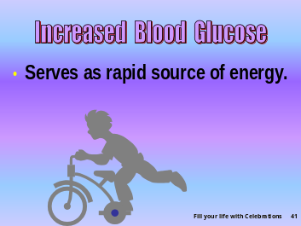 | *Stress causes an increase in blood glucose (to serve as a rapid source of energy); in the diabetically predisposed, chronic stress may lead to the hastening of the onset or exacerbation of diabetes mellitus.
Slide 38 | 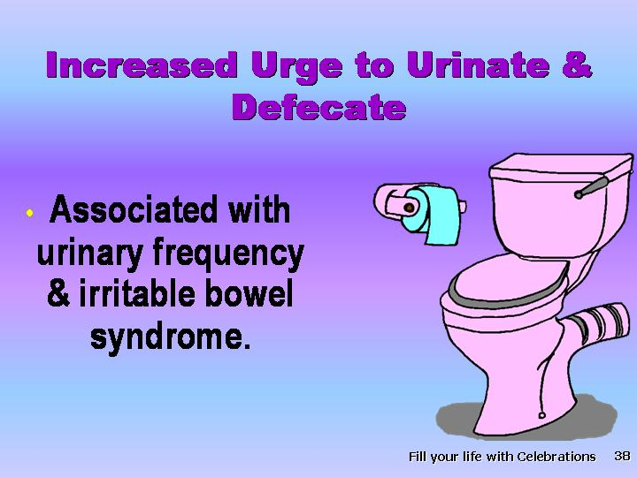 | *Stress may cause alterations in gastrointestinal and urinary functions. Some may suffer from urinary frequency and irritable bowel syndrome.
Slide 39 | 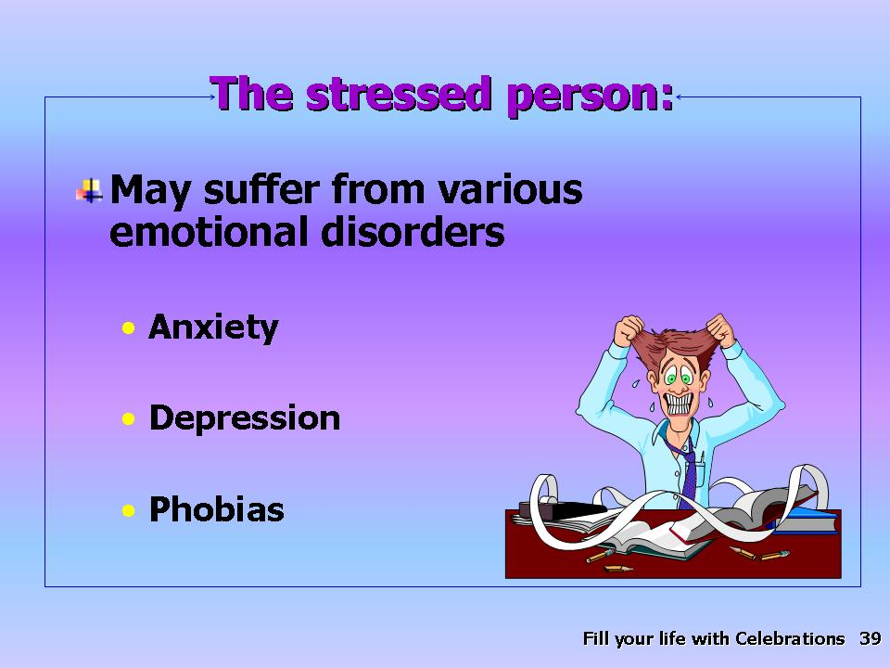 | *A stressed person may visit the doctor for numerous physical complaints and may suffer from emotional disorders such as anxiety, depression, phobias,
Slide 40 | 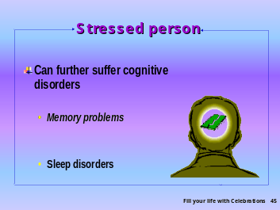 | *cognitive disorders, memory problems, and sleep disorders.
Slide 41 | 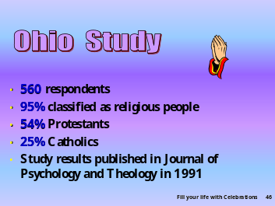 | *In an Ohio study regarding the effects of prayer on well-being, there were altogether 560 respondents, 95 percent of whom classified themselves as religious people; Fifty-four percent were Protestants and 25 percent Catholics.
Slide 42 | 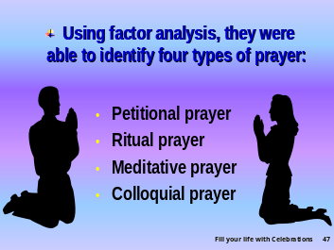 | *Using factor analysis, they were able to identify four types of prayer, namely:
Slide 43 |  | *Petitional prayer; praying to God for material things you may need.
Slide 44 |  | *Ritual prayer; praying to God by reading the book of prayers.
Slide 45 | 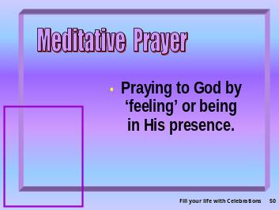 | *Meditative prayer; praying to God by “feeling” or being in His presence.
Slide 46 | 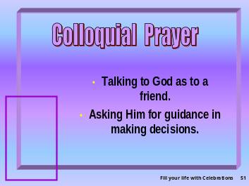 | *Colloquial prayer; praying to God as talking to a friend and asking Him for guidance in making decisions.
Slide 47 | 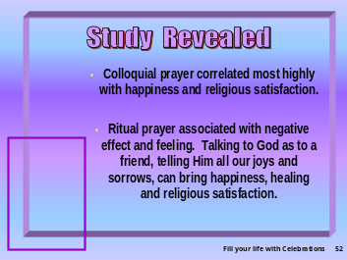 | *Of all these types of prayer, the study revealed that colloquial prayer correlates best with happiness and religious satisfaction; whereas, ritual prayer is associated with a negative effect and feelings all the more sad, lonely, tense, and fearful .Talking to God as to a friend, telling Him all our joys and sorrows, can bring happiness, healing, and religious satisfaction. So important is the role of prayer in healing that
Slide 48 | 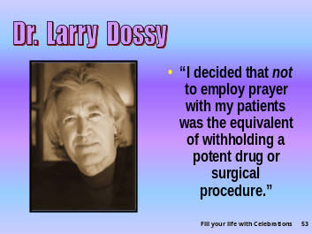 | *Dr. Larry Dossey stated, “I decided that not to employ prayer with my patients was the equivalent of withholding a potent drug or surgical procedure.”
Slide 49 | 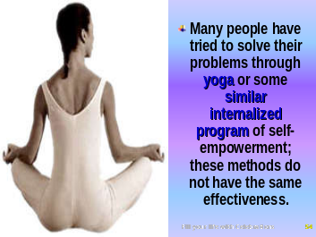 | *Many people have tried to solve their problems through yoga or some similar internalized program of self-empowerment; however, these methods do not have the same effectiveness.
Slide 50 | 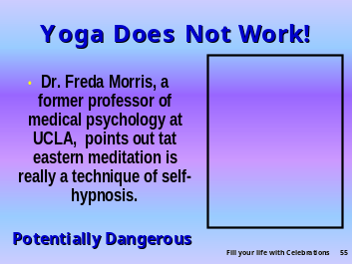 | Dr. Freda Morris, former professor of medical psychology at the University of California Los Angeles, points out that in many cases these programs are really techniques of self-hypnosis.
Slide  51 |  | *The Bible says, “You will keep him in perfect peace, whose mind is stayed on You, because he trusts in You. (Isa. 26:3, NKJV).
Slide 52 |  | *When we have a close relationship with God, we experience peace of mind.
Slide 53 | 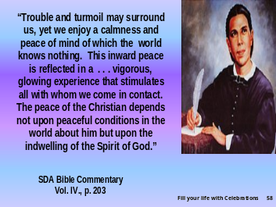 | This does not mean that our lives will be exempt from problems. * “Trouble and turmoil may surround us, yet we enjoy a calmness and peace of mind of which the world knows nothing. This inward peace is reflected in a . . . vigorous, glowing experience that stimulates all with whom we come in contact. The peace of the Christian depends not upon peaceful conditions in the world about him but upon the indwelling of the Spirit of God.”
Slide 54 |  | *As the poet Power said:  Trust in yourself, and you are doomed to disappointment.  Trust in your friends, and they will die and leave you.  Trust your money, and you may have it taken from you.  Trust in reputation, and some slanderous tongue may blast it.  But—trust in God, and you are never to be confounded in time or eternity.
Slide 55 |  | Trust and reliance in a loving powerful God give the ability to enjoy a healthful lifestyle. *Such complete belief in God permits Him
Slide 56 |  | *to fill our lives with CELEBRATIONS!
Slide 57 | 

Levin JS, Vanderpool HY. “Is frequent religious attendance really conducive to better health? Toward an epidemiology of religion”, Soc Sci Med 1987;24(7):589-600.
? Kark JD, et al. Amer J Pub Health, 1996: 86(3);341-6.
? Levin JS, Chatters LM, Taylor RJ. “Religious effects on health status and life satisfaction among black Americans,” J Gerontol B Psychol Sci Soc Sci, 1995 May;50(3):S154-163.
? Ellison CG. “A Race, Religious Involvement and Depressive Symptomatology in a South Eastern US Community,” Soc Sci Med, 1995:40(11);1561-72.
? Shoenback VJ, et al. “Social Ties and Mortality in Evans County GA,” Amer J Epid, 1986; 123: 577-91.
Ellison CG. “Religious involvement and subjective well-being,” J Health soc Behav, 1991 Mar;32(1):80-90.
Dwyer JW, Clarke LL, Miller MK. “The effect of religious concentration and affiliation on county cancer mortality rates,” J Health Soc Behav, 1990 Jun;31(2):185-202.
Koenig HG. Power of Healing Faith, p.72, 1999 Quoting P H Hardestyn and K M Kirby. “Relation Between Family Religious and Drug Use Within Adolescent Peer Groups,” J Soc Behavior and Personality 10:(1) 1995;42-30.
Amoatin & SJ Bahr. “ Religion, Family and Adolescent Drug Use” Soc Perspectives 29:(1) 1986;53-76.
. The Healing Power of Faith (Simon & Schuster: April, 1999), p.177.
Marks J. “A Time Out,” U.S. News & World Report, 11 Dec. 1995:85-97.
Journal of Psychology & Theology, 1991; 19(1):71-83.
Dossey L. Healing Words: The Power of Prayer and the Practice of Medicine (New York: HarperCollins Publisher, 1993) p. xviii.
SDA Bible Commentary, vol. 4, p. 203.

